

Christ Nagar, Hullahalli, Begur - Koppa Road, Sakalwara-Post, Bengaluru-560083

DEPARTMENT OF COMPUTER SCIENCE AND APPLICATIONS

PROJECT REPORT ON

“PERSONAL AUTOMATION INTELLIENCE”

Submitted in partial fulfilment of the requirements for the award of a degree in

BACHELOR OF COMPUTER APPLICATIONS

Submitted by

LIKITHA SHETTY B R (ROLL NO: P03BV23S126045)

Under the guidance of

MS NAYANA K V ASSISTANT PROFESSOR
DEPARTMENT OF COMPUTER SCIENCE AND APPLICATIONS OC MAY/ JUNE - 2026



Christ Nagar, Hullahalli, Begur - Koppa Road, Sakalwara, Post, Bengaluru-560083

DEPARTMENT OF COMPUTER SCIENCE AND APPLICATIONS

Date:

CERTIFICATE

This is to certify that the project work entitled “PERSONAL AUTOMATION INTELLIGENCE” is a Bonafide work done by LIKITHA SHETTY B R (P03BV23S126045) of III Semester in partial fulfilment of requirements for the award of the degree of Master of Computer Applications at CHRIST ACADEMY INSTITUTE FOR ADVANCED STUDIES, affiliated with Bangalore University, during the academic year 2025-2026. It is satisfactory and hereby approved for submission.

Ms Nayana K V Mr Ramesh Babu
(Project Guide) (Head of the Department)

Examiners:

1.

2. College Seal



Christ Nagar, Hullahalli, Begur - Koppa Road, Sakalwara, Post, Bengaluru-560083

DEPARTMENT OF COMPUTER SCIENCE AND APPLICATIONS

Acknowledgement

First, I would like to thank all the people at Christ Academy Institute for Advanced Studies who assisted me in completing my mini-project with their patience.

I acknowledge the help of these individuals with great pleasure and immense gratitude.

I am highly indebted to the Principal, Principal Fr. Antony Pottokaran CMI, and Joint Director
Rev. Fr. Joy Payyappilly CMI, for the facilities provided to accomplish this project.

I would like to thank my Project Guide, Ms Nayana K. V, Department Head, Mr Ramesh Babu, and Program Coordinator, Dr Kavipriya K, for their constructive criticism throughout my project.

I am extremely grateful to my department staff members and friends who helped me complete this project successfully.

Likitha Shetty B R P03BV23S126045

DECLARATION

This is to certify that the project report entitled “PERSONAL AUTOMATION INTELLIGENCE” is done by me, and it is authentic work carried out for the partial fulfilment of the requirements for the award of the degree of Master of Computer Applications (MCA) under the guidance of Ms Nayana K V. The matter and software embodied in this project have not been submitted earlier for award of any degree or diploma to the best of my knowledge and believes.

Date: Signature of Student
Likitha Shetty B R P03BV23S126045

INDEX | PAGE NO
1. INTRODUCTION | 01
1.1 Project Description | 02
1.2 Problem Statement | 03
1.3 Existing System | 04
1.4 Limitations of Existing System | 04
1.5 Proposed System | 05
1.6 Objectives | 05
1.7 Benefits of the Proposed System | 06
2. SYSTEM REQUIREMENTS | 07
2.1 Hardware Specification | 08
2.2 Software Specification | 09
2.3 Tools Survey | 10
2.3.1 Google Sheets API | 10
2.3.2 Gemini API | 10
2.3.3 OpenAI API | 11
2.3.4 SERP API | 11
2.3.5 Hacker News API | 11
2.3.6 n8n Workflow Automation | 12
2.3.7 HTML | 12
2.3.8 CSS | 12
2.3.9 JavaScript | 13
3. SYSTEM DESIGN | 14
3.1 Modules | 15
3.1.1 Personal Assistant Core (Orchestrator  Module) | 15
3.1.2 Contact Database Module | 15
3.1.3 Email Agent Module | 16
3.1.4 Calendar Agent Module | 16
3.1.5 Research Agent Module | 16
3.1.6 Voice Processing Module | 17
3.2 Use-Case Diagram | 17
3.2.1 Use Case and Architecture Diagrams | 17

3.2.1.1 Overall Use Case Diagram | 17
3.2.1.2 Email Agent Use Case Diagram | 18
3.2.1.3 Calendar Agent Use Case Diagram | 18
3.2.1.4 High-Level Architecture Diagram | 18
3.3 Database Design | 19
3.3.1 Contacts Table | 19
4. CODING | 20
4.1 Frontend | 21
4.1.1 Frontend Code | 22
4.1.1.1 index.html | 22
4.1.1.2 src/main.tsx | 23
4.1.1.3 src/app.tsx | 23
4.1.1.4 src/index.css | 34
4.2 Backend | 35
4.2.1 Backend Code | 37
4.2.1.1 PAI Start Agent | 37
4.2.1.2 Email Agent | 54
4.2.1.3 Calendar Agent | 61
4.2.1.4 Research Agent | 70
5. IMPLEMENTATION | 76
5.1 Implementation Overview | 77
5.2 Environment Setup | 77
5.3 Screenshots | 78
5.3.1 Frontend | 78
5.3.2 Backend Workflows | 80
5.3.2.1 PAI Start Workflow | 80
5.3.2.2 Email Agent Workflow | 81
5.3.2.3 Calendar Agent Workflow | 81
5.3.2.4 Research Agent Workflow | 81
6. TESTING | 82
6.1 System Testing | 83
6.2 Integration Testing | 84
6.3 Unit Testing | 85

6.4 Test Case 1: Email Automation | 86
6.5 Test Case 2: Event Scheduling | 87
6.6 Test Case 3: Research Query | 87
6.7 Test Case 4: Voice Integration | 87
6.8 Testing Tools Used | 88
6.9 Test Summary | 88
6.10 Screenshots | 89
7. CONCLUSION | 92
8. FUTURE ENHANCEMENT | 95
8.1 Expansion of AI Capabilities | 96
8.2 Integration with more API’s and Services | 97
8.3 Security and Privacy Improvements | 97
8.4 Intelligent Notifications and Predictive  Automation | 98
8.5 Summary of Future Enhancements | 98
9. REFERENCES | 100
9.1 Books and Academic References | 101
9.2 Websites and Online Resources | 101

INTRODUCTION

INTRODUCTION
In the era of rapid digital transformation, the demand for intelligent systems capable of automating tasks and enhancing personal productivity has grown exponentially. Individuals and organizations now rely on artificial intelligence to manage complex workflows, data operations, and communication tasks. The project PAI – Personal Automation Intelligence (Personal Assistant AI Agent using n8n Workflow Automation) is designed to address this need by combining AI-driven intelligence with workflow automation, creating a fully integrated personal assistant capable of understanding natural language, performing automated actions, and interacting seamlessly with multiple services.

PAI leverages advanced AI models such as Gemini API and OpenAI for natural language understanding, reasoning, and conversational interaction. It utilizes n8n, an open-source workflow automation platform, as its core orchestration layer. The system connects with various APIs—including Google Cloud Console, Google Sheets API, Gmail API, Google Calendar API, SerpAPI, and Hacker News API—to execute real-world automation such as sending emails, scheduling meetings, retrieving research information, and summarizing news content. Unlike traditional virtual assistants, PAI is modular, customizable, and privacy- focused, allowing users to control and extend its capabilities without dependency on proprietary ecosystems.

The project also integrates OpenAI’s Text-to-Speech and Whisper Speech Recognition to enable voice-based interaction, providing users with a natural and intuitive communication interface. By combining these components through n8n’s visual automation workflows, the system delivers both intelligence and execution power, turning user commands into actionable outcomes in real time.

Through this project, the goal is to demonstrate how open-source automation tools and cutting- edge AI models can merge to create an efficient, scalable, and intelligent assistant that simplifies day-to-day digital operations. PAI – Personal Automation Intelligence is not just a tool—it represents the evolution of personal digital assistants into fully autonomous, context- aware systems designed to enhance human capability and efficiency.

PROJECT DESCRIPTION
In the modern era of digital transformation, automation and artificial intelligence (AI) have become critical enablers of efficiency and productivity. Individuals and organizations increasingly rely on intelligent systems to handle repetitive and data-driven tasks, thereby freeing human effort for strategic and creative activities. The project PAI – Personal Automation Intelligence (Personal Assistant AI Agent using n8n Workflow Automation) is a next-generation intelligent assistant designed to bridge the gap between traditional digital assistants and full-fledged automation systems.

The PAI system is an AI-powered, modular, and extensible personal assistant that leverages the open-source n8n workflow automation platform to orchestrate multiple APIs and services intelligently. It integrates state-of-the-art AI tools and web services such as Google

Cloud Console, Google Sheets API, Gemini API, OpenAI API, SerpAPI, and Hacker News API. Each integration contributes a specialized capability — data storage, content retrieval, natural language processing, or speech generation — to create a holistic automation ecosystem.

The architecture follows an event-driven workflow model, in which the system orchestrates independent modules for handling communication, research, scheduling, email automation, and voice interactions. The orchestrator acts as the “brain” of the assistant, processing user inputs (text or voice) and delegating tasks to relevant modules through the n8n environment.

The project’s novelty lies in its fusion of workflow automation and conversational intelligence, allowing users to automate actions through natural language commands. Instead of coding or scripting automation manually, users can type or speak requests such as “Schedule a meeting with Riya at 4 PM tomorrow,” and the system interprets the intent, validates data, connects to Google Calendar, and executes the event automatically.

This assistant not only saves time but also ensures data consistency, operational transparency, and privacy by allowing self-hosted deployment. PAI is built to demonstrate how modern AI agents can transcend rule-based systems and evolve into context-aware digital companions.

PROBLEM STATEMENT
The proliferation of online tools and digital services has led to increased fragmentation of personal and professional workflows. Managing emails, schedules, notifications, and research information typically requires constant switching between applications and devices. This fragmentation results in:

- Reduced productivity due to context switching.
- Difficulty in maintaining synchronization across platforms.
- Dependence on proprietary ecosystems that restrict user control and customization.
- Privacy concerns arising from centralized data storage by third-party assistants.

Conventional digital assistants such as Google Assistant, Siri, and Alexa provide limited support for cross-platform automation and often restrict integration with external APIs or self- hosted services. Similarly, automation tools like Zapier or IFTTT are either paid, closed- source, or have limited flexibility for AI integration.

Hence, the problem is the absence of a unified, privacy-first, AI-driven personal automation system that can interpret natural language, integrate heterogeneous data sources, and execute actions seamlessly.

PAI addresses this gap by offering an open, intelligent, and extensible solution. It utilizes AI to understand user intent and employs modular workflow automation to execute complex, multi- step actions dynamically.

EXISTING SYSTEM
The current landscape of personal assistants and automation systems can be categorized into three main classes:

- Voice-Based Virtual Assistants: Systems like Google Assistant, Siri, and Alexa focus on speech interaction but remain confined to specific ecosystems. They provide simple automation such as reminders or smart device control but lack deep contextual understanding or third-party extensibility.
- Automation Tools: Services such as Zapier and Make (formerly Integromat) enable workflow automation using predefined templates. However, they require technical configuration and are not conversational.
- AI Chatbots: Platforms like ChatGPT or Gemini excel in text-based interaction and reasoning but do not inherently perform real-world automation (like sending an email or creating calendar events).

Thus, existing systems either excel in conversation or automation, but not both simultaneously.

Moreover, they often store user data in centralized clouds, posing potential security and privacy risks. The high subscription costs of enterprise-level automation further limit accessibility for individual users or small organizations.

LIMITATIONS OF EXISTING SYSTEM
The limitations of existing systems can be summarized as follows:

- Lack of Customization: Proprietary platforms limit user control over automation rules and integrations.
- Fragmented Ecosystem: Separate tools are required for communication, scheduling, and research tasks.
- Privacy Concerns: Centralized cloud processing increases data exposure risk.
- Limited Extensibility: Most commercial assistants cannot integrate new APIs easily.
- Cost: Advanced automation features often require paid subscriptions.
- Lack of Contextual Awareness: Assistants often fail to connect user queries across sessions or adapt to user preferences.

These limitations motivated the development of PAI, a self-hosted, extensible system combining workflow automation and AI reasoning.

PROPOSED SYSTEM
The Proposed System – PAI integrates automation with intelligence. It leverages n8n, an open- source, node-based workflow automation tool, to design and orchestrate interconnected workflows for tasks such as email management, scheduling, and research. The orchestration is augmented with AI-driven modules that interpret natural language, extract actionable items, and route them to corresponding agents.

Key design highlights:

- n8n Workflow Engine: Acts as the backbone for defining modular and reusable workflows.
- OpenAI API: Powers natural language understanding and text generation.
- Google Sheets API: Manages dynamic contact and event data storage.
- Gemini API: Provides conversational intelligence and enhanced reasoning.
- SerpAPI & Hacker News API: Used for research queries and news extraction.
- Google Cloud Console: Serves as the cloud environment for managing APIs, authentication, and logging.
- OpenAI TTS: Converts assistant responses into natural speech for interactive use.

This combination results in a self-contained personal automation ecosystem that is customizable, scalable, and context-aware.

OBJECTIVES
The main objectives of the system are:

- To create a conversational AI assistant that performs intelligent task automation.
- To automate scheduling, emailing, and research workflows through integrated APIs.
- To design a modular and reusable architecture based on n8n workflows.
- To provide both text and speech-based interaction channels.
- To ensure data privacy through self-hosting and controlled access.
- To demonstrate interoperability between AI reasoning and real-world automation.
- To provide scalability for future enhancements (adding new agents or APIs).

BENEFITS OF THE PROPOSED SYSTEM
The proposed PAI system provides multiple benefits over conventional assistants:

- Unified Platform: Combines automation, communication, and reasoning.
- High Customizability: Users can modify workflows without coding.
- Privacy-Focused: Data remains within the user’s environment.
- Extensible: Supports integration of additional APIs and workflows.
- Multimodal Interaction: Supports both voice and text.
- Cost-Effective: Built using open-source frameworks and free-tier APIs.
- AI-Powered: Contextual understanding improves response accuracy.
- Scalable Architecture: Designed for expansion with minimal reconfiguration.

SYSTEM REQUIREMENTS

SYSTEM REQUIREMENTS
A successful system implementation depends on clearly defined requirements that guide development, integration, and deployment. The system requirements define the essential components needed to design, build, and operate PAI – Personal Automation Intelligence (Personal Assistant AI Agent using n8n Workflow Automation).

These requirements are broadly categorized into hardware specifications, software specifications, and a tools survey, each crucial for ensuring the stability, performance, and scalability of the solution.

HARDWARE SPECIFICATION
Since PAI is a cloud-enabled and workflow-based system, it requires modest hardware resources when deployed on local or virtualized infrastructure. The following specifications represent the baseline and recommended configurations:

Minimum Hardware Requirements
Component Specification
Processor Intel Core i3 / AMD Ryzen 3 or equivalent
RAM 4 GB
Storage 20 GB available space
Network Stable internet connection (minimum 5 Mbps)

Input/Output Devices
Microphone and speaker for voice interaction, keyboard and display for text-based interaction

Recommended Hardware Requirements
Component Specification
Processor Intel Core i5 / AMD Ryzen 5 or higher
RAM 8 GB or more
Storage 100 GB SSD
Network Broadband connection (10 Mbps or higher)
GPU (Optional) NVIDIA GPU with CUDA support for AI model acceleration
Audio Devices HD microphone, noise-cancelling headset, and stereo output

The assistant can run locally, on a private server, or via cloud-based hosting (e.g., Google Cloud). The flexibility of n8n allows the deployment to scale based on hardware resources.

SOFTWARE SPECIFICATIONS
The system utilizes a combination of software libraries, frameworks, and APIs to enable AI reasoning, workflow orchestration, and data integration.

Operating System

- Ubuntu 22.04 LTS / Windows 10 or above / macOS Monterey Chosen for its stability and compatibility with n8n, Node.js, and Docker containers.
Core Software Components
Software Description

n8n Workflow Automation
Node.js (v18 or higher)
npm (Node Package Manager)
Open-source automation tool used as the backbone for orchestrating tasks and API connections.
Runtime environment supporting JavaScript-based workflow execution.
Used to install and manage dependencies for AI and automation modules.

Docker (Optional) Provides containerized deployment for scalable, isolated workflow instances.

Python (v3.10 or higher)
Used for AI-related modules and data processing tasks when necessary.

Google Cloud SDK Enables management of APIs, credentials, and logging through the Google Cloud Console.

OpenAI SDK / API Client
Facilitates natural language understanding and text-to-speech conversion.

Gemini API SDK Enables conversational and contextual AI features through
Google’s Gemini models.
Google Sheets API Serves as a lightweight database for contact management and task tracking.
SerpAPI Provides search engine query results programmatically for research purposes.
Hacker News API Fetches trending technology and research news for assistant summaries.
Telegram Bot API Used for bidirectional communication between the user and the assistant (text and voice input/output).

Database and Data Storage

- Google Sheets (used as a structured spreadsheet-based database).
- Optional integration with PostgreSQL or MongoDB for large-scale data persistence.

Programming Languages

- JavaScript / TypeScript for workflow automation and scripting in n8n.
- Python for AI and API integration tasks.

TOOLS SURVEY
This section presents a detailed overview of all technologies and APIs used in the PAI project
— their role, importance, and advantages.

GOOGLE SHEETS API

Description:
The Google Sheets API allows applications to read, write, and update data within spreadsheets programmatically. It provides a lightweight, flexible alternative to a traditional database.

Use in PAI:
The assistant uses Google Sheets as a contact and task database. The API enables:

- Storing user contact details (name, email, phone).
- Logging meeting schedules and task lists.
- Synchronizing workflow-generated data for easy access.
- Sharing and updating records dynamically.

GEMINI API

Description:
The Gemini API is Google’s advanced large language model interface that enables deep reasoning, contextual conversation, and multimodal understanding. It acts as a cognitive engine for natural language tasks.

Use in PAI:
PAI leverages Gemini API for intelligent intent recognition and semantic interpretation of user inputs. It assists in:

- Understanding natural language commands.
- Generating context-aware conversational responses.
- Extracting actionable entities such as names, dates, or tasks.
- Summarizing content or research articles fetched by other modules.

OPENAI API

Description:
The OpenAI API provides state-of-the-art natural language processing capabilities through models like GPT and Whisper. It is used for text generation, summarization, translation, and speech-related tasks.

Use in PAI:
PAI integrates OpenAI in two main components:

- Language Understanding: Interprets user prompts, generates summaries, and constructs email content.
- Text-to-Speech (TTS): Converts the assistant’s responses into natural, human-like speech — replacing ElevenLabs as the primary TTS engine.

SERP API

Description:
The SerpAPI (Search Engine Results API) provides real-time access to search results from platforms like Google, Bing, and DuckDuckGo. It eliminates the need for web scraping and provides structured search data.

Use in PAI:
The Research Module in PAI uses SerpAPI to retrieve relevant information from the web based on user queries. For instance, when a user asks “Show me the latest updates on artificial intelligence,” the assistant fetches summarized results from trusted sources via SerpAPI.

HACKER NEWS API

Description:
The Hacker News API is an open data interface that provides access to trending stories, news, and discussions in the technology and startup domain.

Use in PAI:
PAI integrates Hacker News API to fetch recent articles, news summaries, and discussions related to technology. This data is then summarized using AI models and presented to users.

N8N WORKFLOW AUTOMATION

Description:
The n8n platform is the backbone of PAI’s architecture. It is a free, open-source, node-based automation tool that allows connecting APIs, services, and logic modules visually.

Use in PAI:

- Defines all workflow logic between modules.
- Handles triggers, condition checks, and sequential task execution.
- Ensures modular and reusable design for future extensions.

HTML

Hypertext markup language is a basic of creating web page. The internet is latest technology of exchanging information. Even the corporate sector is investing a large amount of money in creating web site and marking their presence felt. Hypertext markup language was envisioned to be format for allowing people using different computers to share information seamlessly over the network.

HTML is the backbone of web development and is essential for creating content that can be viewed and interacted with on the World Wide Web. It forms the foundation upon which cascading style sheets (CSS) and JavaScript are built to create visually appealing and interactive web experiences.

CSS

CSS (Cascading Style Sheets) is a stylesheet language used to describe the presentation of a document written in HTML or XML (including XML dialects such as SVG or XHTML). CSS describes how elements should be rendered on screen, on paper, in speech, or on other media.

CSS is a fundamental technology for web development, enabling developers to separate content from presentation and create visually appealing and responsive web pages. It works alongside HTML and JavaScript to create interactive and engaging user experiences on the web.

Features of CSS

- Custom properties
- Feature queries.
- Media queries
- Variable fonts
- Graphical effects

JAVASCRIPT

JavaScript is a versatile and powerful programming language primarily used for creating dynamic and interactive web content.

Cross-platform Compatibility: JavaScript is supported by all modern web browsers, including Chrome, Firefox, Safari, Edge, and Opera, making it a cross-platform language. It can also be used in other environments outside the browser, such as server-side development with Node.js, desktop application development with frameworks like Electron, and mobile app development with frameworks like React Native.

Libraries and Frameworks: JavaScript has a vast ecosystem of libraries and frameworks that extend its capabilities and simplify common tasks. Some popular libraries include jQuery for DOM manipulation, Lodash for utility functions, and Moment.js for date and time manipulation. Frameworks like React, Angular, and Vue.js provide tools for building complex web applications with reusable components and state management.

JavaScript is a fundamental technology for web development, enabling developers to create dynamic and interactive experiences for users across a wide range of devices and platforms. Its versatility and widespread adoption make it an essential skill for web developers and a cornerstone of modern web development.

SYSTEM DESIGN

SYSTEM DESIGN
System design represents the architectural blueprint of the PAI project. It defines the flow of data, interconnections between modules, and the logical framework required for seamless integration of automation and artificial intelligence. The purpose of this phase is to convert the functional and non-functional requirements into structured modules, ensuring scalability, modularity, and maintainability.

The PAI system follows an event-driven modular design, where each module functions as an independent microservice or workflow node. The Orchestrator module, powered by n8n, acts as the central brain that coordinates communication between all submodules.

MODULES
The PAI system consists of several major modules that collectively deliver intelligent automation and interaction capabilities. Each module is autonomous, reusable, and communicates via standardized data formats (JSON or API payloads).

PERSONAL ASSISTANT CORE (ORCHESTRATOR MODULE)

- The central processing unit of the system.
- Responsible for receiving user inputs via Telegram or other chat interfaces.
- Identifies intent using AI models (OpenAI / Gemini).
- Routes the request to the appropriate submodule (Email, Calendar, Research, etc.).
- Formats and returns responses in text or audio form.
- Maintains conversation context to ensure continuity in user interaction.

Functions:

- Intent recognition and task routing.
- Session management.
- Input-output formatting.
- Error handling and fallback communication.

CONTACT DATABASE MODULE

- Handles all user contact data for integration with Email and Calendar modules.
- Uses Google Sheets API as a dynamic, lightweight database.
- Stores attributes such as name, email address, and phone number.
- Allows fast lookup and retrieval for email sending or event scheduling.

Functions:

- Contact creation, modification, and deletion.
- API-based search and retrieval.
- Acts as a shared database across modules.

EMAIL AGENT MODULE

- Integrates with Gmail API to send, receive, and summarize emails.
- Supports filters such as sender, subject, or date range.
- Uses AI summarization (OpenAI or Gemini) to condense long email threads.
- Ensures professional formatting and automatic sign-off for replies.

Functions:

- Fetching and sending emails.
- Auto-summarization of inbox messages.
- Voice-based email dictation (using STT/TTS).
- Integration with contact and calendar modules.

CALENDAR AGENT MODULE

- Connected with Google Calendar API for event creation and retrieval.
- Allows users to schedule meetings or view upcoming events through voice or text.
- Handles conflict detection and rescheduling using AI reasoning.
- Sends automatic confirmations via email.

Functions:

- Event scheduling and cancellation.
- Time-slot checking and reminders.
- Synchronization with user contact database.

RESEARCH AGENT MODULE

- Responsible for performing research and information retrieval.
- Uses a multi-source approach for query processing:
  - Wikipedia → Hacker News → SerpAPI priority chain.
- Fetches data, validates credibility, and generates short summaries.
- AI models analyze retrieved data to provide concise, readable outputs.

Functions:
- Keyword-based search and data aggregation.
- AI-based summarization and contextual formatting.

- Support for follow-up questions to refine research.

VOICE PROCESSING MODULE

- Handles audio input and output for human-like interaction.
- Converts voice commands to text using OpenAI Whisper (STT).
- Converts text responses back to audio using OpenAI TTS (replacing ElevenLabs).
- Enables seamless bidirectional communication.

Functions:

- Speech-to-text and text-to-speech processing.
- Audio stream handling.
- Optional offline fallback if API latency occurs.

USE CASE DIAGRAM

USE CASE AND ARCHITECTURE DIAGRAMS
      - Overall Use Case Diagram
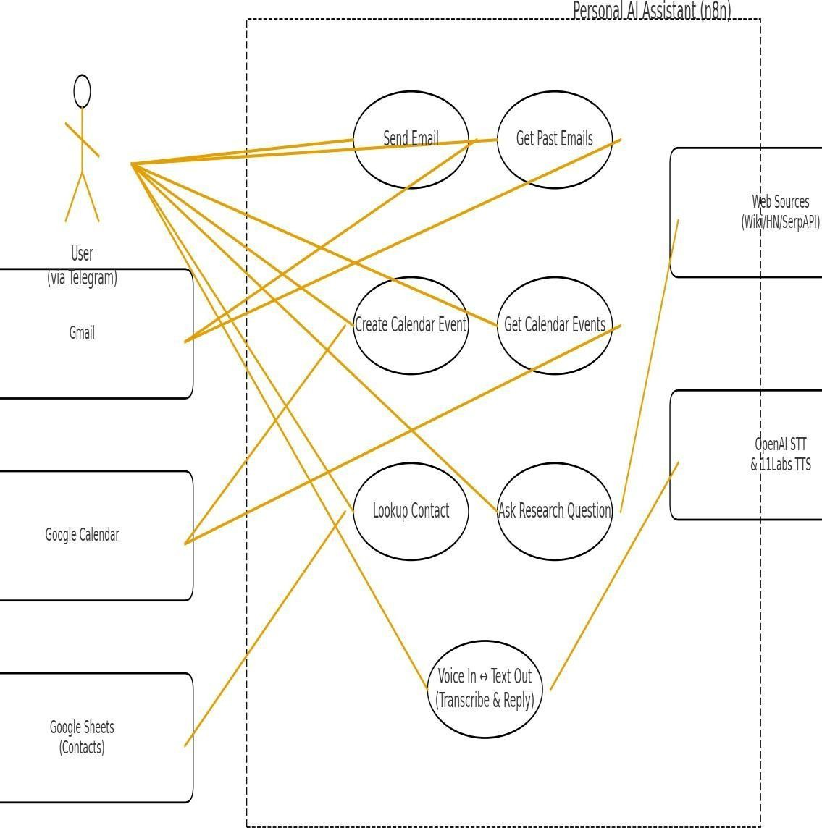

      - Email Agent Use Case Diagram
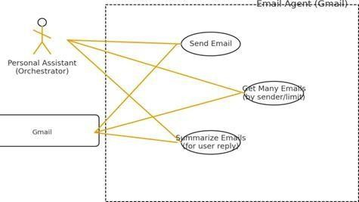

      - Calendar Agent Use Case Diagram

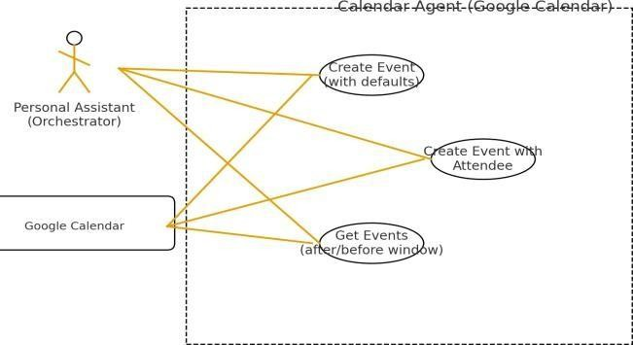

      - High-Level Architecture Diagram

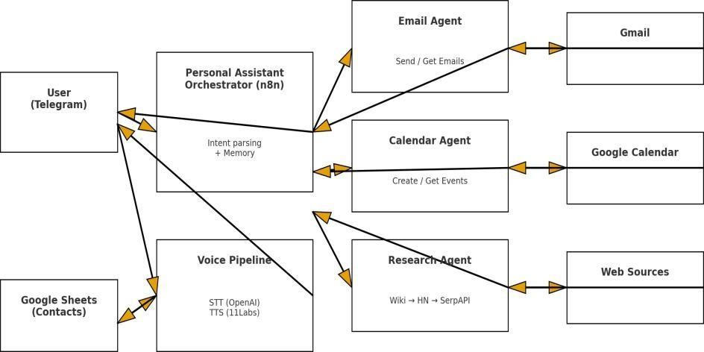

DATABASE DESIGN
Unlike traditional systems that rely on heavy relational databases, PAI uses a lightweight, cloud- based Google Sheets database for ease of access, simplicity, and portability. This approach minimizes complexity while providing flexibility for small- to medium-scale users.

CONTACTS TABLE

Field | Type | Description
Name | Text | Contact’s name
Email | Text | Contact’s email address
Phone | Text | Contact number
Added On | Date | Date of entry creation

Explanation:

- The Contacts Table serves as the primary data source for both the Email Agent and Calendar Agent modules.
- When the assistant needs to send an email or schedule an event, it queries this sheet for a matching contact name or email address.
- Entries can be added manually by the user or automatically by the assistant during new interactions.
- Since it’s hosted on Google Sheets, data can be viewed or edited easily, ensuring transparency and control.

Advantages of Using Google Sheets:

- No server setup or database maintenance.
- Secure and authenticated access via Google Cloud Console.
- Real-time synchronization across all modules.
- Easy export/import in CSV format

CODING

CODING
The coding phase represents the implementation stage of the system development life cycle (SDLC), where all the design specifications are translated into executable workflows and programmatic logic.
In the case of PAI, the implementation is unique — instead of traditional source code alone, it combines visual workflows (n8n nodes), API integrations, and AI model prompts into an integrated automation system.

The system consists of two major layers of implementation:

- Frontend Layer – responsible for user interaction through text and voice and detailed PAI website.
- Backend Layer – responsible for logic processing, workflow orchestration, and data integration.
Each of these layers connects through n8n’s workflow engine, which executes logic in a sequence of nodes.

FRONTEND
The frontend layer acts as the communication bridge between the user and the system. Instead of a web UI, the assistant primarily uses Telegram and voice interfaces for input/output. It receives text or voice commands, forwards them to the backend, and displays or speaks the responses generated by the assistant.

Core Components:

- Telegram Bot API Integration
  - Handles sending and receiving of messages.
  - Uses webhook or polling methods to listen to user input.
  - Each user message triggers a workflow node in n8n.
  - Provides response delivery in both text and voice formats.

Voice Input/Output (OpenAI STT/TTS)
  - Speech-to-text conversion via OpenAI Whisper model.
  - Text-to-speech via OpenAI TTS API, producing human-like voice responses.
  - Audio streaming handled asynchronously to ensure minimal delay.

User Interface Layer (Optional)
  - For advanced users, a web dashboard or chatbot interface may be integrated.
  - Displays email summaries, event lists, and logs.
  - Implements search and filter functions for easier navigation.

Workflow Trigger Example:

- User sends: “Create a meeting with Riya tomorrow at 3 PM.”
- Telegram forwards this message to n8n through a webhook.
- The workflow trigger node activates the Orchestrator module.
- Output is formatted and sent back to Telegram with a confirmation reply.

Advantages:

- Lightweight frontend without heavy UI frameworks.
- Platform-independent communication (mobile or desktop Telegram app).
- Supports both voice and text interaction.

FRONTEND CODE

Folder Structure
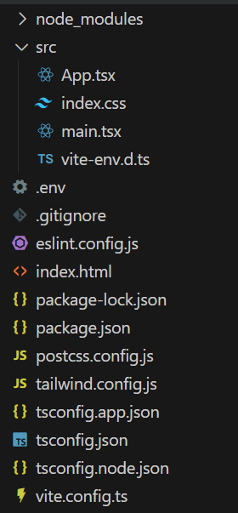
      - Index.html

<!doctype html>
<html lang="en">
<head>
<meta charset="UTF-8" />
<link rel="icon" type="image/svg+xml" href="/vite.svg" />
<meta name="viewport" content="width=device-width, initial-scale=1.0" />
<title>PAI</title>
</head>
<body>
<div id="root"></div>
<script type="module" src="/src/main.tsx"></script>
</body>
</html>

src/main.tsx

import { StrictMode } from 'react';
import { createRoot } from 'react-dom/client'; import App from './App.tsx';
import './index.css';
createRoot(document.getElementById('root')!).render(
<StrictMode>
<App />
</StrictMode>
);

src/app.tsx

import { Bot, Calendar, Mail, Database, Search, ArrowRight, CheckCircle2, Zap, Shield, Workflow, ArrowUp } from 'lucide-react';
import { useEffect, useState } from 'react';
function App() {
const [showBackToTop, setShowBackToTop] = useState(false);

useEffect(() => {
const handleScroll = () => {
const scrolled = window.scrollY;
const windowHeight = window.innerHeight;
const documentHeight = document.documentElement.scrollHeight;

if (scrolled > windowHeight || (scrolled + windowHeight >= documentHeight - 100)) { setShowBackToTop(true);
} else { setShowBackToTop(false);
}
};

window.addEventListener('scroll', handleScroll);
return () => window.removeEventListener('scroll', handleScroll);
}, []);

const scrollToTop = () => {
window.scrollTo({ top: 0, behavior: 'smooth' });
};

return (
<div className="min-h-screen bg-gradient-to-br from-slate-50 to-slate-100">
<header className="bg-white shadow-sm sticky top-0 z-50 backdrop-blur-sm bg- white/95">
<div className="max-w-7xl mx-auto px-4 sm:px-6 lg:px-8 py-4">
<div className="flex items-center justify-between">

<div className="flex items-center space-x-3">
<div className="bg-blue-600 p-2 rounded-lg">
<Bot className="w-6 h-6 text-white" />
</div>
<h1 className="text-2xl font-bold text-slate-900">PAI</h1>
</div>
<nav className="hidden md:flex space-x-8">
<a href="#about" className="text-slate-600 hover:text-blue-600
transition">About</a>
<a href="#workflow" className="text-slate-600 hover:text-blue-600 transition">Workflow</a>
<a href="#comparison" className="text-slate-600 hover:text-blue-600 transition">Comparison</a>
<a href="#telegram" className="text-slate-600 hover:text-blue-600 transition">Try
Now</a>
</nav>
</div>
</div>
</header>

<section className="pt-20 pb-32 px-4 sm:px-6 lg:px-8 relative overflow-hidden">
<div className="absolute inset-0 z-0 opacity-10">
<img
src="https://images.pexels.com/photos/8386440/pexels-photo-8386440.jpeg" alt="AI Background"
className="w-full h-full object-cover"
/>
</div>
<div className="max-w-7xl mx-auto text-center relative z-10">
<div className="inline-block mb-6 px-4 py-2 bg-blue-100 text-blue-700 rounded-full text-sm font-semibold">
Personal Automation Intelligence
</div>
<h2 className="text-5xl md:text-6xl font-bold text-slate-900 mb-6 leading-tight"> Automate smarter.<br />Work faster.<br />Think intelligently.
</h2>
<p className="text-xl text-slate-600 mb-12 max-w-3xl mx-auto">
An AI-powered personal assistant that understands context, automates workflows, and manages your tasks through intelligent multi-agent coordination.
</p>
<div className="flex flex-col sm:flex-row gap-4 justify-center mb-12">
<a
href="#workflow"
className="inline-flex items-center justify-center px-8 py-4 bg-blue-600 text-white rounded-lg font-semibold hover:bg-blue-700 transition shadow-lg hover:shadow-xl"
>
Explore Workflow
<ArrowRight className="ml-2 w-5 h-5" />
</a>

<a
href="#telegram"
className="inline-flex items-center justify-center px-8 py-4 bg-white text-blue-600 rounded-lg font-semibold hover:bg-slate-50 transition shadow-md border-2 border-blue-600"
>
Try on Telegram
</a>
</div>
<div className="mt-16 rounded-2xl overflow-hidden shadow-2xl border-4 border-white max-w-5xl mx-auto">
<img
src="https://images.pexels.com/photos/7688336/pexels-photo-7688336.jpeg" alt="AI Assistant Dashboard"
className="w-full h-auto"
/>
</div>
</div>
</section>

<section id="about" className="py-20 px-4 sm:px-6 lg:px-8 bg-white">
<div className="max-w-7xl mx-auto">
<div className="text-center mb-16">
<h3 className="text-3xl md:text-4xl font-bold text-slate-900 mb-4">What is
PAI?</h3>
<p className="text-lg text-slate-600 max-w-3xl mx-auto">
PAI is a self-hosted personal automation intelligence system built on n8n workflows
and AI.
It extracts user intent from natural language, coordinates multiple specialized agents,
and executes complex automation tasks.
</p>
</div>

300"
<div className="grid md:grid-cols-2 lg:grid-cols-4 gap-8">
<div className="p-6 rounded-xl bg-slate-50 hover:bg-slate-100 transition group">
<div className="relative mb-4 h-40 rounded-lg overflow-hidden">
<img
src="https://images.pexels.com/photos/5582590/pexels-photo-5582590.jpeg" alt="Email Management"
className="w-full h-full object-cover group-hover:scale-105 transition duration-

/>
<div className="absolute inset-0 bg-blue-600/20"></div>
<div className="absolute top-3 left-3 bg-blue-100 w-12 h-12 rounded-lg flex items- center justify-center">
<Mail className="w-6 h-6 text-blue-600" />
</div>
</div>
<h4 className="text-xl font-semibold text-slate-900 mb-2">Email Management</h4>
<p className="text-slate-600">

Compose, send, and organize emails intelligently. AI finishes drafts and manages correspondence.
</p>
</div>

300"
<div className="p-6 rounded-xl bg-slate-50 hover:bg-slate-100 transition group">
<div className="relative mb-4 h-40 rounded-lg overflow-hidden">
<img
src="https://images.pexels.com/photos/5717455/pexels-photo-5717455.jpeg" alt="Smart Scheduling"
className="w-full h-full object-cover group-hover:scale-105 transition duration-

/>
<div className="absolute inset-0 bg-green-600/20"></div>
<div className="absolute top-3 left-3 bg-green-100 w-12 h-12 rounded-lg flex items- center justify-center">
<Calendar className="w-6 h-6 text-green-600" />
</div>
</div>
<h4 className="text-xl font-semibold text-slate-900 mb-2">Smart Scheduling</h4>
<p className="text-slate-600">
Create events, manage calendars, and coordinate meetings with context-aware
scheduling.
</p>
</div>

300"
<div className="p-6 rounded-xl bg-slate-50 hover:bg-slate-100 transition group">
<div className="relative mb-4 h-40 rounded-lg overflow-hidden">
<img
src="https://images.pexels.com/photos/5483077/pexels-photo-5483077.jpeg" alt="Contact Database"
className="w-full h-full object-cover group-hover:scale-105 transition duration-

/>
<div className="absolute inset-0 bg-orange-600/20"></div>
<div className="absolute top-3 left-3 bg-orange-100 w-12 h-12 rounded-lg flex items-center justify-center">
<Database className="w-6 h-6 text-orange-600" />
</div>
</div>
<h4 className="text-xl font-semibold text-slate-900 mb-2">Contact Database</h4>
<p className="text-slate-600">
Access and query contact information seamlessly integrated with all automation
workflows.
</p>
</div>

<div className="p-6 rounded-xl bg-slate-50 hover:bg-slate-100 transition group">
<div className="relative mb-4 h-40 rounded-lg overflow-hidden">

300"
<img
src="https://images.pexels.com/photos/5428836/pexels-photo-5428836.jpeg" alt="Research Agent"
className="w-full h-full object-cover group-hover:scale-105 transition duration-

/>
<div className="absolute inset-0 bg-purple-600/20"></div>
<div className="absolute top-3 left-3 bg-purple-100 w-12 h-12 rounded-lg flex items-center justify-center">
<Search className="w-6 h-6 text-purple-600" />
</div>
</div>
<h4 className="text-xl font-semibold text-slate-900 mb-2">Research Agent</h4>
<p className="text-slate-600">
Search Wikipedia, Hacker News, and the web to answer questions with accurate information.
</p>
</div>
</div>
</div>
</section>
<section id="workflow" className="py-20 px-4 sm:px-6 lg:px-8 bg-slate-50">
<div className="max-w-7xl mx-auto">
<div className="text-center mb-16">
<h3 className="text-3xl md:text-4xl font-bold text-slate-900 mb-4">How PAI Works</h3>
<p className="text-lg text-slate-600 max-w-3xl mx-auto">
Multi-agent coordination powered by n8n workflows and AI language models
</p>
</div>
<div className="mb-16 rounded-2xl overflow-hidden shadow-2xl">
<img
src="https://images.pexels.com/photos/8386434/pexels-photo-8386434.jpeg" alt="Workflow Architecture"
className="w-full h-auto"
/>
</div>

<div className="bg-white rounded-2xl shadow-xl p-8 md:p-12">
<div className="grid md:grid-cols-3 gap-8 mb-12">
<div className="text-center">
<div className="bg-blue-600 w-16 h-16 rounded-full flex items-center justify-center mx-auto mb-4">
<span className="text-white text-2xl font-bold">1</span>
</div>
<h4 className="text-xl font-semibold text-slate-900 mb-2">Input Processing</h4>
<p className="text-slate-600">

Gemini.
User sends text or voice command via Telegram. Voice is transcribed using Google

</p>
</div>

<div className="text-center">
<div className="bg-green-600 w-16 h-16 rounded-full flex items-center justify- center mx-auto mb-4">
<span className="text-white text-2xl font-bold">2</span>
</div>
<h4 className="text-xl font-semibold text-slate-900 mb-2">Intent Recognition</h4>
<p className="text-slate-600">
AI parses the request and routes to specialized agents: Email, Calendar, Research, or Contacts.
</p>
</div>

<div className="text-center">
<div className="bg-purple-600 w-16 h-16 rounded-full flex items-center justify- center mx-auto mb-4">
<span className="text-white text-2xl font-bold">3</span>
</div>
<h4 className="text-xl font-semibold text-slate-900 mb-2">Task Execution</h4>
<p className="text-slate-600">
Agents execute tasks using Google Gemini and OpenAI, then return results via text
or audio.
</p>
</div>
</div>

<div className="border-t border-slate-200 pt-12">
<h4 className="text-2xl font-bold text-slate-900 mb-8 text-center">Agent Architecture</h4>
<div className="grid md:grid-cols-2 lg:grid-cols-4 gap-6">
<div className="p-6 border-2 border-blue-200 rounded-xl bg-blue-50 hover:shadow- lg transition">
<div className="flex items-center mb-3">
<Mail className="w-5 h-5 text-blue-600 mr-2" />
<h5 className="font-semibold text-slate-900">Email Agent</h5>
</div>
<ul className="text-sm text-slate-600 space-y-1">
<li>• Send emails</li>
<li>• Get messages</li>
<li>• Draft completion</li>
<li>• Gmail integration</li>
</ul>
</div>

<div className="p-6 border-2 border-green-200 rounded-xl bg-green-50 hover:shadow-lg transition">
<div className="flex items-center mb-3">
<Calendar className="w-5 h-5 text-green-600 mr-2" />
<h5 className="font-semibold text-slate-900">Calendar Agent</h5>
</div>
<ul className="text-sm text-slate-600 space-y-1">
<li>• Create events</li>
<li>• Add attendees</li>
<li>• Get schedules</li>
<li>• Google Calendar</li>
</ul>
</div>

<div className="p-6 border-2 border-orange-200 rounded-xl bg-orange-50 hover:shadow-lg transition">
<div className="flex items-center mb-3">
<Database className="w-5 h-5 text-orange-600 mr-2" />
<h5 className="font-semibold text-slate-900">Contact Database</h5>
</div>
<ul className="text-sm text-slate-600 space-y-1">
<li>• Query contacts</li>
<li>• Retrieve details</li>
<li>• Google Sheets</li>
<li>• Auto-lookup</li>
</ul>
</div>

<div className="p-6 border-2 border-purple-200 rounded-xl bg-purple-50 hover:shadow-lg transition">
<div className="flex items-center mb-3">
<Search className="w-5 h-5 text-purple-600 mr-2" />
<h5 className="font-semibold text-slate-900">Research Agent</h5>
</div>
<ul className="text-sm text-slate-600 space-y-1">
<li>• Wikipedia search</li>
<li>• Hacker News API</li>
<li>• SERP API</li>
<li>• Smart fallback</li>
</ul>
</div>
</div>
</div>
</div>
</div>
</section>

<section id="comparison" className="py-20 px-4 sm:px-6 lg:px-8 bg-white">
<div className="max-w-7xl mx-auto">

<div className="text-center mb-16">
<h3 className="text-3xl md:text-4xl font-bold text-slate-900 mb-4">Why Choose PAI?</h3>
<p className="text-lg text-slate-600 max-w-3xl mx-auto">
See how PAI compares to other automation and assistant technologies
</p>
</div>
<div className="overflow-x-auto">
<table className="w-full bg-white rounded-xl shadow-lg overflow-hidden">
<thead className="bg-slate-900 text-white">
<tr>
<th className="px-6 py-4 text-left font-semibold">Feature</th>
<th className="px-6 py-4 text-center font-semibold">PAI</th>
<th className="px-6 py-4 text-center font-semibold">Google Assistant</th>
<th className="px-6 py-4 text-center font-semibold">ChatGPT Automations</th>
<th className="px-6 py-4 text-center font-semibold">Zapier</th>
</tr>
</thead>
<tbody className="divide-y divide-slate-200">
<tr className="hover:bg-slate-50">
<td className="px-6 py-4 font-medium text-slate-900">Multi-Agent
Coordination</td>
<td className="px-6 py-4 text-center"><CheckCircle2 className="w-6 h-6 text- green-600 mx-auto" /></td>
<td className="px-6 py-4 text-center"><span className="text-slate-400">—
</span></td>
<td className="px-6 py-4 text-center"><span className="text-slate-
400">Limited</span></td>
<td className="px-6 py-4 text-center"><span className="text-slate-400">—
</span></td>
</tr>
<tr className="hover:bg-slate-50">
<td className="px-6 py-4 font-medium text-slate-900">Context-Aware
Reasoning</td>
<td className="px-6 py-4 text-center"><CheckCircle2 className="w-6 h-6 text- green-600 mx-auto" /></td>
<td className="px-6 py-4 text-center"><span className="text-slate- 400">Basic</span></td>
<td className="px-6 py-4 text-center"><CheckCircle2 className="w-6 h-6 text- green-600 mx-auto" /></td>
<td className="px-6 py-4 text-center"><span className="text-slate-400">—
</span></td>
</tr>
<tr className="hover:bg-slate-50">
<td className="px-6 py-4 font-medium text-slate-900">Self-Hosted & Private</td>
<td className="px-6 py-4 text-center"><CheckCircle2 className="w-6 h-6 text- green-600 mx-auto" /></td>

</span></td>

</span></td>

</span></td>
<td className="px-6 py-4 text-center"><span className="text-slate-400">—

<td className="px-6 py-4 text-center"><span className="text-slate-400">—

<td className="px-6 py-4 text-center"><span className="text-slate-400">—

</tr>
<tr className="hover:bg-slate-50">
<td className="px-6 py-4 font-medium text-slate-900">JSON-Based
Workflows</td>
<td className="px-6 py-4 text-center"><CheckCircle2 className="w-6 h-6 text- green-600 mx-auto" /></td>
<td className="px-6 py-4 text-center"><span className="text-slate-400">—
</span></td>
<td className="px-6 py-4 text-center"><span className="text-slate-400">—
</span></td>
<td className="px-6 py-4 text-center"><CheckCircle2 className="w-6 h-6 text- green-600 mx-auto" /></td>
</tr>
<tr className="hover:bg-slate-50">
<td className="px-6 py-4 font-medium text-slate-900">Enterprise
Automation</td>
<td className="px-6 py-4 text-center"><CheckCircle2 className="w-6 h-6 text- green-600 mx-auto" /></td>
<td className="px-6 py-4 text-center"><span className="text-slate-400">—
</span></td>
<td className="px-6 py-4 text-center"><span className="text-slate-
400">Limited</span></td>
<td className="px-6 py-4 text-center"><CheckCircle2 className="w-6 h-6 text- green-600 mx-auto" /></td>
</tr>
<tr className="hover:bg-slate-50">
<td className="px-6 py-4 font-medium text-slate-900">Cost</td>
<td className="px-6 py-4 text-center"><span className="text-green-600 font- semibold">Free/Low</span></td>
<td className="px-6 py-4 text-center"><span className="text-green-600 font- semibold">Free</span></td>
<td className="px-6 py-4 text-center"><span className="text-orange-600 font- semibold">$20+/mo</span></td>
<td className="px-6 py-4 text-center"><span className="text-orange-600 font- semibold">$20+/mo</span></td>
</tr>
<tr className="hover:bg-slate-50">
<td className="px-6 py-4 font-medium text-slate-900">Customization</td>
<td className="px-6 py-4 text-center"><span className="text-blue-600 font- semibold">Full</span></td>
<td className="px-6 py-4 text-center"><span className="text-slate- 400">Limited</span></td>

<td className="px-6 py-4 text-center"><span className="text-slate- 400">Moderate</span></td>
<td className="px-6 py-4 text-center"><span className="text-blue-600 font- semibold">High</span></td>
</tr>
</tbody>
</table>
</div>
<div className="grid md:grid-cols-3 gap-8 mt-16">
<div className="p-8 bg-gradient-to-br from-blue-50 to-blue-100 rounded-2xl border- 2 border-blue-200 hover:shadow-xl transition">
<Zap className="w-12 h-12 text-blue-600 mb-4" />
<h4 className="text-xl font-bold text-slate-900 mb-2">Intelligent Coordination</h4>
<p className="text-slate-700">
Multiple specialized agents work together seamlessly, sharing context and coordinating complex workflows.
</p>
</div>

<div className="p-8 bg-gradient-to-br from-green-50 to-green-100 rounded-2xl border-2 border-green-200 hover:shadow-xl transition">
<Shield className="w-12 h-12 text-green-600 mb-4" />
<h4 className="text-xl font-bold text-slate-900 mb-2">Privacy First</h4>
<p className="text-slate-700">
Self-hosted on your infrastructure. Your data never leaves your control. Full transparency and security.
</p>
</div>

<div className="p-8 bg-gradient-to-br from-purple-50 to-purple-100 rounded-2xl border-2 border-purple-200 hover:shadow-xl transition">
<Workflow className="w-12 h-12 text-purple-600 mb-4" />
<h4 className="text-xl font-bold text-slate-900 mb-2">Open Architecture</h4>
<p className="text-slate-700">
Built on n8n with JSON workflows. Easily extend, customize, and integrate with any service or API.
</p>
</div>
</div>
</div>
</section>

<section id="telegram" className="py-20 px-4 sm:px-6 lg:px-8 bg-gradient-to-br from- blue-600 to-blue-800 text-white relative overflow-hidden">
<div className="absolute inset-0 opacity-10">
<img
src="https://images.pexels.com/photos/4050299/pexels-photo-4050299.jpeg" alt="Communication Background"

className="w-full h-full object-cover"
/>
</div>
<div className="max-w-4xl mx-auto text-center relative z-10">
<div className="inline-block p-4 bg-white/10 rounded-2xl mb-6">
<svg className="w-20 h-20" viewBox="0 0 240 240" fill="none">
<circle cx="120" cy="120" r="120" fill="white"/>
<path d="M81.229 128.772l14.237 39.406s1.78 3.687 3.686 3.687 30.255-29.492
30.255-29.492l31.525-60.89L81.737 118.6" fill="#c8daea"/>
<path d="M100.106 138.878l-2.733 29.046s-1.144 8.9 7.754 0 17.415-15.763 17.415-
15.763" fill="#a9c6d8"/>
<path d="M81.486 130.178l-38.565-12.07s-4.632-1.857-3.165-6.066c.307-.876 1.003-1.638 2.897-3.086 8.479-6.492 128.03-48.683 128.03-48.683s4.346-1.49 7.024-
.892c.89.198 1.755.662 2.397 1.876.643 1.215.993 2.663.993 4.091 0 .86-.156 1.724-.464
2.584-.613 1.706-1.855 7.877-3.097 14.168l-12.48 68.048s-.978 7.008-5.844 7.196c-
1.617.063-3.25-.307-4.86-.993-2.634-.998-22.353-13.605-29.694-19.893-1.232-1.057-2.207-
2.39-2.831-3.898-.623-1.507-.886-3.154-.73-4.79.156-1.636.73-3.211 1.62-4.567 1.785-2.724
13.997-14.168 29.694-28.813 1.57-1.438 2.207-3.086.73-3.86-1.478-.773-3.397-.307-
5.348.922-3.909 2.467-32.736 21.273-48.908 31.393-2.055 1.284-4.508 2.006-7.024 2.006-
1.571 0-3.142-.307-4.632-.922-2.897-1.193-8.48-3.086-12.816-4.564z" fill="#2481cc"/>
</svg>
</div>
<h3 className="text-4xl font-bold mb-4">Try PAI on Telegram</h3>
<p className="text-xl mb-8 text-blue-100">
Experience the power of Personal Automation Intelligence right now. Send commands via text or voice and watch PAI handle your tasks.
</p>
<a
href="http://t.me/Sirpi_MyOCR_bot" target="_blank"
rel="noopener noreferrer"
className="inline-flex items-center justify-center px-10 py-5 bg-white text-blue-600 rounded-lg font-bold text-lg hover:bg-blue-50 transition shadow-2xl hover:shadow-3xl transform hover:scale-105"
>
<svg className="w-6 h-6 mr-3" viewBox="0 0 240 240" fill="none">
<path d="M81.486 130.178l-38.565-12.07s-4.632-1.857-3.165-6.066c.307-.876 1.003-1.638 2.897-3.086 8.479-6.492 128.03-48.683 128.03-48.683s4.346-1.49 7.024-
.892c.89.198 1.755.662 2.397 1.876.643 1.215.993 2.663.993 4.091 0 .86-.156 1.724-.464
2.584-.613 1.706-1.855 7.877-3.097 14.168l-12.48 68.048s-.978 7.008-5.844 7.196c-
1.617.063-3.25-.307-4.86-.993-2.634-.998-22.353-13.605-29.694-19.893-1.232-1.057-2.207-
2.39-2.831-3.898-.623-1.507-.886-3.154-.73-4.79.156-1.636.73-3.211 1.62-4.567 1.785-2.724
13.997-14.168 29.694-28.813 1.57-1.438 2.207-3.086.73-3.86-1.478-.773-3.397-.307-
5.348.922-3.909 2.467-32.736 21.273-48.908 31.393-2.055 1.284-4.508 2.006-7.024 2.006-
1.571 0-3.142-.307-4.632-.922-2.897-1.193-8.48-3.086-12.816-4.564z" fill="currentColor"/>
</svg>
Open Telegram Bot
</a>
<p className="mt-6 text-blue-200 text-sm">

Examples: "Send an email to John" • "Schedule a meeting tomorrow at 3pm" • "Search for AI news"
</p>
</div>
</section>
<footer className="bg-slate-900 text-white py-12 px-4 sm:px-6 lg:px-8">
<div className="max-w-7xl mx-auto text-center">
<div className="flex items-center justify-center space-x-3 mb-4">
<div className="bg-blue-600 p-2 rounded-lg">
<Bot className="w-6 h-6 text-white" />
</div>
<h1 className="text-2xl font-bold">PAI</h1>
</div>
<p className="text-slate-400 mb-4">Personal Automation Intelligence</p>
<p className="text-slate-500 text-sm">
Built with n8n • Powered by AI • Open Source
</p>
<p className="text-slate-500 text-sm mt-2"> Presented by Likitha Shetty B R • MCA 4th Semester
</p>
</div>
</footer>
<button onClick={scrollToTop}
className={`fixed bottom-8 right-8 bg-blue-600 text-white p-4 rounded-full shadow-2xl hover:bg-blue-700 transition-all duration-300 z-50 ${
showBackToTop ? 'opacity-100 translate-y-0' : 'opacity-0 translate-y-16 pointer-events-
none'
}`}
aria-label="Back to top"
>
<ArrowUp className="w-6 h-6" />
</button>
</div>
);
}

export default App;

4.1.1.4 src/index.css

@tailwind base; @tailwind components; @tailwind utilities;

html {
scroll-behavior: smooth;

}

@layer utilities {
.shadow-3xl {
box-shadow: 0 35px 60px -15px rgba(0, 0, 0, 0.3);
}
}

BACKEND
The backend layer of PAI is the system’s operational core. It manages intent recognition, API execution, and workflow sequencing. It is responsible for connecting AI reasoning with automation logic.

Core Components:

- n8n Workflow Engine:
  - The central environment where automation logic is implemented.
  - Each process (e.g., sending an email, adding an event, or fetching data) is represented as a workflow containing multiple nodes.
  - Nodes can include function nodes, HTTP request nodes, or AI integration nodes.

AI Integration Layer (OpenAI & Gemini):
  - Responsible for processing user queries and determining intent.
  - Example prompt:
“Analyze this input and return whether it’s an email task, a calendar task, or a research query.”

  - The AI response determines which workflow branch executes next.

Google API Connectors:
  - Gmail API: Sends and retrieves emails using authenticated access tokens.
  - Google Sheets API: Reads and updates contact information dynamically.
  - Google Calendar API: Creates or retrieves scheduled events.
  - Each API call includes OAuth 2.0 tokens for secure communication.

Research Integrations:
  - SerpAPI: Retrieves relevant search results for general knowledge queries.
  - Hacker News API: Fetches technology-related news items.
  - AI summarizes long data into concise responses for readability.

Data Logging & Monitoring:
  - Each completed workflow logs execution time, success/failure status, and summary messages.
  - Logs are stored in Google Sheets (under a “Logs” tab) for easy inspection.

Error Handling:
  - Built-in retry mechanisms in n8n nodes for transient failures.
  - Fallback responses from the Orchestrator if APIs are unreachable.
  - Example fallback: “I was unable to contact Google Calendar. Please try again later.”

Example Workflow: Email Sending Process Step-by-step sequence executed inside n8n:
- Trigger Node: Telegram receives the command → “Send an email to Rahul about project updates.”
- AI Intent Node: OpenAI interprets that this is an email task.
- Contact Lookup Node: Google Sheets API searches for “Rahul” in the Contacts Table.
- Email Compose Node: OpenAI drafts a polite message.
- Email Send Node: Gmail API sends the email.
- Response Node: Confirmation sent to the user – “Email successfully sent to Rahul.”
- Log Node: Saves action summary in Google Sheets.

This workflow executes in under five seconds, ensuring real-time responsiveness.

Example Workflow: Calendar Scheduling Process Sequence:
- User command: “Schedule a meeting with Priya at 2 PM tomorrow.”
- AI parses entities:
  - Task Type: “Schedule”
  - Attendee: “Priya”
  - Time: “2 PM”
  - Date: “Tomorrow”
- Contact Database fetches Priya’s email.
- Google Calendar API creates an event.
- System responds:

“Meeting with Priya has been scheduled for tomorrow at 2 PM.”

- Entry logged in the Logs Sheet for audit.

Error Handling Example
Scenario System Behavior
API timeout Retry API call up to 3 times before notifying user
Missing contact Prompts: “I don’t have this contact saved. Would you like to add it?”
Invalid date Suggests correction: “I couldn’t recognize the date. Did you mean tomorrow?”
TTS failure Responds with text fallback message AI misclassification Logs misinterpreted query for review

Security Implementation

Security is paramount when dealing with personal data and third-party integrations. The following security measures are implemented in the backend:

- OAuth 2.0 Authentication: Used for all Google services.
- Token Encryption: API credentials are stored securely in environment variables.
- Access Control: Only authorized workflows are executed through defined triggers.
- Activity Logs: All operations are timestamped and stored in the Logs Sheet for transparency.

Integration Summary

Component | Technology Used | Purpose
User Input | Telegram Bot API / Voice Input | Capturing user queries
AI Processing | OpenAI API / Gemini API | Intent detection and text generation
Data Management | Google Sheets API | Contact storage
Email Operations | Gmail API | Sending and summarizing emails
Scheduling | Google Calendar API | Event creation and reminders
Web Research | SerpAPI / Hacker News API | Information and news retrieval
Workflow Engine | n8n | Task orchestration
Speech Output | OpenAI TTS | Natural voice responses
Authentication | OAuth 2.0 | Secure access control

    - Backend code
      - PAI Start Agent
{
"name": "PAI start", "nodes": [
{
"parameters": { "model": {
" rl": true,
"value": "gpt-4o-mini",
"mode": "list", "cachedResultName": "gpt-4o-mini"
},
"options": {}
},
"type": "@n8n/n8n-nodes-langchain.lmChatOpenAi", "typeVersion": 1.2,
"position": [
-1456,
1376

],
"id": "987d75f8-9c7e-4872-b8d5-4d73a3f9178f",
"name": "OpenAI Chat Model1", "credentials": {
"openAiApi": {
"id": "***********", "name": "OpenAi account"
}
}
},
{
"parameters": { "options": {}
},
"type": "@n8n/n8n-nodes-langchain.lmChatGoogleGemini", "typeVersion": 1,
"position": [
-672,
1456
],
"id": "eb63472a-a4ea-457a-a373-e19cda0599e7", "name": "Google Gemini Chat Model", "credentials": {
"googlePalmApi": { "id": "*********",
"name": "Google Gemini(PaLM) Api account 3"
}
}
},
{
"parameters": { "updates": [ "message"
],
"additionalFields": {}
},
"type": "n8n-nodes-base.telegramTrigger", "typeVersion": 1.2,
"position": [
-1120,
1104
],
"id": "8ed33a81-1897-4a4b-9477-baca2c644340",
"name": "Telegram Trigger",
"webhookId": "059ad393-d2bf-4d59-9d77-f042f661a831", "credentials": {
"telegramApi": { "id": "*********",
"name": "Sirpi_MyOCR_bot"

}
}
},
{
"parameters": { "rules": {
"values": [
{
"conditions": { "options": { "caseSensitive": true, "leftValue": "",
"typeValidation": "strict", "version": 2
},
"conditions": [
{
"leftValue": "={{ $json.message.voice.file_id }}", "rightValue": "",
"operator": { "type": "string",
"operation": "exists", "singleValue": true
},
"id": "87d50a52-5d17-41ec-a58c-993d4c4ca3df"
}
],
"combinator": "and"
},
"renameOutput": true, "outputKey": "Voice"
},
{
"conditions": { "options": { "caseSensitive": true, "leftValue": "",
"typeValidation": "strict", "version": 2
},
"conditions": [
{
"id": "ee37da98-ba79-4539-a027-577e71740254",
"leftValue": "={{ $json.message.text }}", "rightValue": "",
"operator": { "type": "string",
"operation": "exists", "singleValue": true

}
}
],
"combinator": "and"
},
"renameOutput": true, "outputKey": "Text"
}
]
},
"options": {}
},
"type": "n8n-nodes-base.switch", "typeVersion": 3.2,
"position": [
-912,
1104
],
"id": "b625ee46-9796-4381-bf37-d8e5c6573606",
"name": "Switch"
},
{
"parameters": { "resource": "file",
"fileId": "={{ $json.message.voice.file_id }}", "additionalFields": {}
},
"type": "n8n-nodes-base.telegram", "typeVersion": 1.2,
"position": [
-624,
1008
],
"id": "7be9561b-120e-4146-a4c3-ae0d4a42b096",
"name": "Download File",
"webhookId": "fbbfe2eb-5e52-4a1e-9c9a-ebc16c020640", "credentials": {
"telegramApi": { "id": "**********",
"name": "Sirpi_MyOCR_bot"
}
}
},
{
"parameters": { "resource": "audio", "modelId": {
" rl": true,
"value": "models/gemini-2.5-flash",

"mode": "list",
"cachedResultName": "models/gemini-2.5-flash"
},
"inputType": "binary", "options": {}
},
"type": "@n8n/n8n-nodes-langchain.googleGemini", "typeVersion": 1,
"position": [
-400,
1008
],
"id": "d03acef2-1918-4f78-9520-5a2894353e82",
"name": "Transcribe Audio", "credentials": { "googlePalmApi": {
"id": "*******",
"name": "Google Gemini(PaLM) Api account 3"
}
}
},
{
"parameters": { "assignments": { "assignments": [
{
"id": "1ebe7f9d-be79-4e4c-aea7-70f1934f3de1", "name": "text",
"value": "={{ $json.message.text }}", "type": "string"
}
]
},
"options": {}
},
"type": "n8n-nodes-base.set", "typeVersion": 3.4, "position": [
-512,
1168
],
"id": "103f68a8-e1d3-41ec-90c0-43114ceedf2c", "name": "Set Text"
},
{
"parameters": { "documentId": { " rl": true,
"value": "1k1uJeUZ8C-vjiMQokv7xo_tuuhqGVJti_lrFi0A-ijY",

"mode": "list", "cachedResultName": "My Agent",
"cachedResultUrl": "https://docs.google.com/spreadsheets/d/1k1uJeUZ8C- vjiMQokv7xo_tuuhqGVJti_lrFi0A-ijY/edit?usp=drivesdk"
},
"sheetName": {
" rl": true, "value": "gid=0",
"mode": "list", "cachedResultName": "Sheet1",
"cachedResultUrl": "https://docs.google.com/spreadsheets/d/1k1uJeUZ8C- vjiMQokv7xo_tuuhqGVJti_lrFi0A-ijY/edit#gid=0"
},
"options": {}
},
"type": "n8n-nodes-base.googleSheetsTool", "typeVersion": 4.6,
"position": [ 128,
1456
],
"id": "9af48df5-df87-45ba-8024-9eca816e3320", "name": "Contact Database",
"credentials": { "googleSheetsOAuth2Api": { "id": "*******",
"name": "Google Sheets account"
}
}
},
{
"parameters": {
"description": "=Call this tool to take action in email. Send the query to the sub worflow
\n\n",
"workflowId": { " rl": true,
"value": "we9zcmksVbA31ns9", "mode": "id"
},
"workflowInputs": { "mappingMode": "defineBelow", "value": {}, "matchingColumns": [], "schema": [], "attemptToConvertTypes": false, "convertFieldsToString": false
}
},
"type": "@n8n/n8n-nodes-langchain.toolWorkflow",

"typeVersion": 2.2, "position": [
-352,
1456
],
"id": "7f4ad996-5afb-424b-847c-356f72ea059a", "name": "Email Agent"
},
{
"parameters": { "sessionIdType": "customKey",
"sessionKey": "={{ $('Telegram Trigger').item.json.message.chat.id }}"
},
"type": "@n8n/n8n-nodes-langchain.memoryBufferWindow", "typeVersion": 1.3,
"position": [
-512,
1456
],
"id": "faac0ef6-db27-4231-a9c0-babb1d86ccb2", "name": "Simple Memory"
},
{
"parameters": {
"description": "Call this tool to take action in calendar. Send the query to the sub worflow.\n",
"workflowId": { " rl": true,
"value": "xnhp4N5X16FCsqO7", "mode": "list",
"cachedResultName": "Calendar Agent"
},
"workflowInputs": { "mappingMode": "defineBelow", "value": {}, "matchingColumns": [], "schema": [], "attemptToConvertTypes": false, "convertFieldsToString": false
}
},
"type": "@n8n/n8n-nodes-langchain.toolWorkflow", "typeVersion": 2.2,
"position": [
-192,
1456
],
"id": "b751277f-83e2-452e-a45a-d547a4a51f95",
"name": "Calendar Agent"

},
{
"parameters": {
"description": "=Call this tool to search the internet to answer the user's question. Send the query to the sub worflow.",
"workflowId": { " rl": true,
"value": "89bA6LGh7bkVTkbv", "mode": "list",
"cachedResultName": "Research Agent"
},
"workflowInputs": { "mappingMode": "defineBelow", "value": {}, "matchingColumns": [
"query"
],
"schema": [], "attemptToConvertTypes": false, "convertFieldsToString": false
}
},
"type": "@n8n/n8n-nodes-langchain.toolWorkflow", "typeVersion": 2.2,
"position": [
-32,
1456
],
"id": "2f301d62-46e3-4779-9360-ea2bc1b810e1",
"name": "Research Agent"
},
{
"parameters": { "modelId": {
" rl": true,
"value": "models/gemini-2.5-flash", "mode": "list",
"cachedResultName": "models/gemini-2.5-flash"
},
"messages": {
"values": [
{
"content": "=Summarize this incoming information: {{ $json.output }}\n\nOutput only plain text; there should be no markdown formatting or any symbols, even \\n"
}
]
},
"options": {

"systemMessage": "=Summarize this incoming information: {{ $json.output
}}\n\nOutput only plain text; there should be no markdown formatting or any symbols, even
\\n"
}
},
"type": "@n8n/n8n-nodes-langchain.googleGemini", "typeVersion": 1,
"position": [ 288,
1200
],
"id": "0a8ee87b-751e-4a42-94f2-46bc158cfebb", "name": "Message a model",
"credentials": { "googlePalmApi": { "id": "*********",
"name": "Google Gemini(PaLM) Api account 3"
}
}
},
{
"parameters": { "method": "POST",
"url": "https://api.openai.com/v1/audio/speech", "sendHeaders": true,
"specifyHeaders": "=json", "headerParameters": { "parameters": [
{}
]
},
"jsonHeaders": "={\n\"Authorization\": \"Bearer ****open api key****** \",\n\"Content- Type\": \"application/json\"\n}\n",
"sendBody": true, "specifyBody": "json",
"jsonBody": "={\n \"model\": \"gpt-4o-mini-tts\",\n \"voice\":
\"alloy\",\n \"input\":{{$json[\"content\"][\"parts\"][0][\"text\"]}}\n}\n", "options": {
"response": {
"response": { "responseFormat": "file"
}
}
}
},
"type": "n8n-nodes-base.httpRequest", "typeVersion": 4.2,
"position": [ 640,

1200
],
"id": "0c74ae2e-e3bd-400d-8044-35a1115bf09a", "name": "HTTP Request"
},
{
"parameters": { "operation": "sendAudio",
"chatId": "={{ $('Telegram Trigger').item.json.message.chat.id }}", "binaryData": true,
"additionalFields": { "fileName": "data,.mpeg"
}
},
"type": "n8n-nodes-base.telegram", "typeVersion": 1.2,
"position": [ 848,
1200
],
"id": "55187b2d-5a2a-4545-b5f5-5e9a406b7fe6",
"name": "Audio Response",
"webhookId": "6488b7c1-8758-49f2-a8cb-933a7c0f58af", "credentials": {
"telegramApi": { "id": "********",
"name": "Sirpi_MyOCR_bot"
}
}
},
{
"parameters": {
"chatId": "={{ $('Telegram Trigger').item.json.message.chat.id }}", "text": "={{ $json.output }}",
"additionalFields": { "appendAttribution": false, "parse_mode": "HTML"
}
},
"type": "n8n-nodes-base.telegram", "typeVersion": 1.2,
"position": [ 848,
1008
],
"id": "af8db478-7070-4345-9d1a-7b5363443482",
"name": "Text Response",
"webhookId": "8742af92-f59b-4d40-b9e2-3a797f061c45", "credentials": {

"telegramApi": { "id": "*********",
"name": "Sirpi_MyOCR_bot"
}
}
},
{
"parameters": {
"description": "Retrieves data about Company projects"
},
"type": "@n8n/n8n-nodes-langchain.toolVectorStore", "typeVersion": 1.1,
"position": [ 272,
1456
],
"id": "54f52f4f-8d2e-4038-9573-670657e5a258",
"name": "Answer questions with a vector store"
},
{
"parameters": { "options": {}
},
"type": "@n8n/n8n-nodes-langchain.lmChatGoogleGemini", "typeVersion": 1,
"position": [ 512,
1632
],
"id": "f4bb2654-3228-4c71-be0b-8906ae83ba57",
"name": "Google Gemini Chat Model1", "credentials": {
"googlePalmApi": { "id": "************",
"name": "Google Gemini(PaLM) Api account 3"
}
}
},
{
"parameters": { "pineconeIndex": { " rl": true, "value": "pai",
"mode": "list", "cachedResultName": "pai"
},
"options": { "pineconeNamespace": "=Demo"
}

},
"type": "@n8n/n8n-nodes-langchain.vectorStorePinecone", "typeVersion": 1.3,
"position": [ 192,
1632
],
"id": "b07f6788-e60a-43bb-9dde-60f37bc010f0", "name": "Pinecone Vector Store",
"credentials": { "pineconeApi": { "id": "********",
"name": "PineconeApi account"
}
}
},
{
"parameters": {},
"type": "@n8n/n8n-nodes-langchain.embeddingsGoogleGemini", "typeVersion": 1,
"position": [ 192,
1792
],
"id": "1e275baa-7b92-42ba-9223-e290bd02baa4", "name": "Embeddings Google Gemini", "credentials": {
"googlePalmApi": { "id": "**********",
"name": "Google Gemini(PaLM) Api account 3"
}
}
},
{
"parameters": { "promptType": "=define",
"text": "={{ $json.text }} or {{ $json.content.parts[0].text }}", "options": {
"systemMessage": "=You are a highly efficient and detail-oriented personal assistant AI. Your primary role is to manage communication and scheduling tasks with precision. You have access to three tools Contact Database emailAgent and calendarAgent. Your highest priority is to always use these tools in the correct sequence to ensure accuracy and reliability.\n\nCore Task Rules\n\n1 Always query the Contact Database first. Before using emailAgent or calendarAgent you must confirm the correct contact details. If the contact is not found stop and notify the user. Do not proceed.\n\n2 Email Handling with emailAgent. By default the account to fetch the email from is likithas@gmail.com\n. Only use emailAgent after retrieving the correct email address from the Contact Database. Include the email address in the query. While responding in Telegram do not include responses from the attendee until it is explicitly requested. Ensure all email content is professional and free of placeholders. Tasks include

sending replying forwarding or retrieving past emails.\n\n3 Scheduling with calendarAgent. Use the current date and time as the reference. Only use calendarAgent after verifying contact details from the Contact Database. Tasks include scheduling meetings updating events or canceling events. Always confirm all event details including time date and participants before finalizing. Pass the Gmail ID of attendees in the query if participants are mentioned.\n\nWorkflow Summary\n\nStep 1 Query the Contact Database to retrieve verified contact information including email address and phone number whenever only the name is mentioned in the request.\n\nStep 2 Use emailAgent to perform communication tasks only after the contact has been verified.\n\nStep 3 Use calendarAgent to perform scheduling tasks only after the contact has been verified. Always confirm all details before scheduling or updating events.\n\nReminders\n\nAlways verify contacts before proceeding.\nNever use emailAgent or calendarAgent without confirmed contact details.\nAlways notify the user if a contact cannot be found.\nKeep all emails and event notes clear professional and accurate.\nConsider the current date and time when interpreting and scheduling requests.\n\nExamples\n\nExample 1 Sending an email\nInput Send an email to Sarah Connor Hi Sarah can we reschedule our meeting to next week\nProcess Query Contact Database Sarah Connor sarah.connor@example.com\n\nUse emailAgent Send email\n\nExample 2 Scheduling a meeting\nInput Schedule a meeting with David Brown for Thursday at 2 PM\nProcess Query Contact Database David Brown david.brown@example.com\n\nUse calendarAgent Schedule event with details\n\nExample 3 Contact not found\nInput Send an email to Michael Johnson Please confirm receipt of the documents\nProcess Query Contact Database Michael Johnson NOT FOUND\nOutput I could not find contact information for Michael Johnson Please provide the correct details"
}
},
"type": "@n8n/n8n-nodes-langchain.agent", "typeVersion": 2,
"position": [
-112,
1088
],
"id": "22332f69-e398-4e9d-99a2-6328fbc85a45",
"name": "PAI Start"
}
],
"pinData": {}, "connections": {
"Google Gemini Chat Model": { "ai_languageModel": [
[
{
"node": "PAI Start",
"type": "ai_languageModel", "index": 0
}
]
]
},
"Telegram Trigger": {

"main": [ [
{
"node": "Switch",
"type": "main", "index": 0
}
]
]
},
"Switch": {
"main": [ [
{
"node": "Download File", "type": "main",
"index": 0
}
], [
{
"node": "Set Text",
"type": "main", "index": 0
}
]
]
},
"Download File": { "main": [
[
{
"node": "Transcribe Audio", "type": "main",
"index": 0
}
]
]
},
"Transcribe Audio": { "main": [
[
{
"node": "PAI Start",
"type": "main", "index": 0
}
]
]

},
"Set Text": {
"main": [ [
{
"node": "PAI Start",
"type": "main", "index": 0
}
]
]
},
"Contact Database": { "ai_tool": [
[
{
"node": "PAI Start",
"type": "ai_tool", "index": 0
}
]
]
},
"Email Agent": { "ai_tool": [
[
{
"node": "PAI Start",
"type": "ai_tool", "index": 0
}
]
]
},
"Simple Memory": { "ai_memory": [
[
{
"node": "PAI Start",
"type": "ai_memory", "index": 0
}
]
]
},
"Calendar Agent": { "ai_tool": [
[
{

"node": "PAI Start",
"type": "ai_tool", "index": 0
}
]
]
},
"Research Agent": { "ai_tool": [
[
{
"node": "PAI Start",
"type": "ai_tool", "index": 0
}
]
]
},
"Message a model": { "main": [
[
{
"node": "HTTP Request", "type": "main",
"index": 0
}
]
]
},
"HTTP Request": { "main": [
[
{
"node": "Audio Response", "type": "main",
"index": 0
}
]
]
},
"Answer questions with a vector store": { "ai_tool": [
[
{
"node": "PAI Start",
"type": "ai_tool", "index": 0
}
]

]
},
"Google Gemini Chat Model1": { "ai_languageModel": [
[
{
"node": "Answer questions with a vector store", "type": "ai_languageModel",
"index": 0
}
]
]
},
"Pinecone Vector Store": { "ai_vectorStore": [
[
{
"node": "Answer questions with a vector store", "type": "ai_vectorStore",
"index": 0
}
]
]
},
"Embeddings Google Gemini": { "ai_embedding": [
[
{
"node": "Pinecone Vector Store", "type": "ai_embedding", "index": 0
}
]
]
},
"PAI Start": {
"main": [ [
{
"node": "Text Response", "type": "main",
"index": 0
},
{
"node": "Message a model", "type": "main",
"index": 0
}
]

]
}
},
"active": false, "settings": { "executionOrder": "v1",
"timezone": "Asia/Kolkata",
"callerPolicy": "workflowsFromSameOwner"
},
"versionId": "f9a381c5-fd13-4485-860a-800a59320463",
"meta": { "templateCredsSetupCompleted": true,
"instanceId": "fdff6adfefaa050197c6012149c6f4df9c646394050099b032c8bc37ec779772"
},
"id": "AUzvwGgILNEPHYQk",
"tags": []
}

Email Agent

{
"name": "Email Agent", "nodes": [
{
"parameters": { "inputSource": "passthrough"
},
"type": "n8n-nodes-base.executeWorkflowTrigger", "typeVersion": 1.1,
"position": [
-416,
-48
],
"id": "a6fd66ca-c739-45cd-89fd-120e158df321", "name": "When Executed by Another Workflow"
},
{
"parameters": { "promptType": "define", "text": "={{ $json.query }}", "options": {
"systemMessage": "You are Likitha’s Email Finisher, an AI agent responsible for converting raw or draft email text into a polished, professional, and send-ready message.\n\nYour Objective\n\nAlways return a fully composed email that is ready to send.\n\nAlways end with an appropriate sign-off from “Likitha”.\n\nNever include or retain placeholders such as “[Name]” or “<Company>”.\n\nMaintain the writer’s intended tone and purpose while improving clarity and correctness.\n\nYour Rules\n\nEmail Context Detection\n\nIdentify if the draft is a new email, a reply, or a forward.\n\nAdapt tone

accordingly (professional, polite, concise).\n\nContent and Style\n\nCorrect all grammar, punctuation, and formatting.\n\nKeep tone clear, confident, and natural.\n\nMaintain factual accuracy; never invent details.\n\nRemove placeholders and incomplete data gracefully.\n\nIf a subject line is missing, generate one that fits the context.\n\nSign-Off Rules\n\nAlways close with one valid sign-off from Likitha.\n\nDefault:\n\nBest, \nLikitha\n\n\nIf an existing signature exists, keep only one (cleaned version).\n\nNever add phone numbers, titles, or links unless they appear in the draft.\n\nQuoted Threads\n\nPreserve quoted history exactly as is.\n\nEdit only the new message section above the thread.\n\nEdge Handling\n\nIf details are missing, omit gracefully (“once you confirm, I’ll proceed”) rather than using placeholders.\n\nIf the draft is very short, produce a minimal but complete reply with sign- off.\n\nOutput Format\n\nReturn only the final, send-ready email text.\n\nInclude “Subject: …” if needed.\n\nDo not include reasoning, instructions, or explanations."
}
},
"type": "@n8n/n8n-nodes-langchain.agent", "typeVersion": 2,
"position": [
-144,
-48
],
"id": "95a43daa-83e7-4c42-958d-08e93638d813",
"name": "Email Agent", "alwaysOutputData": false, "retryOnFail": false,
"onError": "continueErrorOutput"
},
{
"parameters": { "model": {
" rl": true,
"value": "gpt-4.1-mini", "mode": "list",
"cachedResultName": "gpt-4.1-mini"
},
"options": {}
},
"type": "@n8n/n8n-nodes-langchain.lmChatOpenAi", "typeVersion": 1.2,
"position": [
-880,
112
],
"id": "4f03d598-10ae-4def-8f82-f1983fbc55d5", "name": "OpenAI Chat Model",
"credentials": { "openAiApi": { "id": "********",
"name": "OpenAi account"
}

}
},
{
"parameters": {
"sendTo": "={{ $fromAI(\"emailAddress\", \"the email address we are sending to\") }}", "subject": "={{ $fromAI(\"subject\") }}",
"emailType": "text",
"message": "={{ $fromAI(\"emailBody\") }}", "options": {
"appendAttribution": false, "senderName": "Likitha"
}
},
"type": "n8n-nodes-base.gmailTool", "typeVersion": 2.1,
"position": [
-240,
240
],
"id": "82fb37aa-804d-4ee0-be03-55693e6b23dc", "name": "Send Email",
"webhookId": "f2e28d67-5dd6-45e1-9c4c-69afe56eb0cd", "credentials": {
"gmailOAuth2": { "id": "*********",
"name": "Gmail account"
}
}
},
{
"parameters": { "operation": "getAll",
"limit": "={{ $fromAI('Limit') }}", "simple": false,
"filters": {
"labelIds": "={{ /*n8n-auto-generated-fromAI-override*/
$fromAI('Label_Names_or_IDs', ``, 'string') }}", "sender": "={{ $fromAI('SenderEmail') }}"
},
"options": {}
},
"type": "n8n-nodes-base.gmailTool", "typeVersion": 2.1,
"position": [
-112,
240
],
"id": "47e8da14-d53d-4d13-a97c-a14a1cc5b25a", "name": "Get messages",

"webhookId": "926bd4ef-6db8-4098-a80d-4a3a4f53736e", "credentials": {
"gmailOAuth2": { "id": "*********",
"name": "Gmail account"
}
}
},
{
"parameters": { "assignments": { "assignments": [
{
"id": "3c97e425-a15f-490c-81dc-9fd414ab3979",
"name": "response",
"value": "={{ $json.output }}", "type": "string"
}
]
},
"options": {}
},
"type": "n8n-nodes-base.set", "typeVersion": 3.4, "position": [
304,
-128
],
"id": "a65bc781-450b-455b-aaab-828d9db8dda8", "name": "Response"
},
{
"parameters": { "operation": "getAll",
"limit": "={{ /*n8n-auto-generated-fromAI-override*/ $fromAI('Limit', ``, 'number') }}", "filters": {}
},
"type": "n8n-nodes-base.gmailTool", "typeVersion": 2.1,
"position": [ 208,
240
],
"id": "01ac4913-4fef-47fd-a6f9-7213b29a9f13", "name": "Get many messages in Gmail",
"webhookId": "70c02b8e-44c6-4957-8d48-2ae119566f09", "credentials": {
"gmailOAuth2": { "id": "*********",

"name": "Gmail account"
}
}
},
{
"parameters": { "operation": "get",
"messageId": "={{ $fromAI('Message_ID') }}"
},
"type": "n8n-nodes-base.gmailTool", "typeVersion": 2.1,
"position": [ 48,
240
],
"id": "b934d232-99a5-498e-bbd2-bdaa28550617",
"name": "Get a message in Gmail",
"webhookId": "2dc22b60-d654-492c-84df-288bf49e3472", "credentials": {
"gmailOAuth2": { "id": "*********",
"name": "Gmail account"
}
}
},
{
"parameters": { "options": {}
},
"type": "@n8n/n8n-nodes-langchain.lmChatGoogleGemini", "typeVersion": 1,
"position": [
-384,
240
],
"id": "b242a186-6a91-4efa-adbd-fe8bf887e594", "name": "Google Gemini Chat Model", "credentials": {
"googlePalmApi": { "id": "*******",
"name": "Google Gemini(PaLM) Api account 3"
}
}
},
{
"parameters": { "assignments": { "assignments": [
{

"id": "ba3dd6ce-c935-4f81-9962-b2a7dc25843a", "name": "response",
"value": "Unable to perform task. Please try Again.", "type": "string"
}
]
},
"options": {}
},
"type": "n8n-nodes-base.set", "typeVersion": 3.4, "position": [
304,
48
],
"id": "52ab3d84-bc34-4ed0-905b-c173cca3e2fb", "name": "Try Again"
}
],
"pinData": {}, "connections": {
"When Executed by Another Workflow": { "main": [
[
{
"node": "Email Agent", "type": "main", "index": 0
}
]
]
},
"OpenAI Chat Model": { "ai_languageModel": [ []
]
},
"Send Email": {
"ai_tool": [ [
{
"node": "Email Agent", "type": "ai_tool", "index": 0
}
]
]
},
"Get messages": {

"ai_tool": [ [
{
"node": "Email Agent", "type": "ai_tool", "index": 0
}
]
]
},
"Email Agent": { "main": [
[
{
"node": "Response",
"type": "main", "index": 0
}
], [
{
"node": "Try Again",
"type": "main", "index": 0
}
]
]
},
"Get many messages in Gmail": { "ai_tool": [
[
{
"node": "Email Agent", "type": "ai_tool", "index": 0
}
]
]
},
"Get a message in Gmail": { "ai_tool": [
[
{
"node": "Email Agent", "type": "ai_tool", "index": 0
}
]
]

},
"Google Gemini Chat Model": { "ai_languageModel": [
[
{
"node": "Email Agent", "type": "ai_languageModel", "index": 0
}
]
]
}
},
"active": false, "settings": { "executionOrder": "v1",
"callerPolicy": "workflowsFromSameOwner", "timezone": "Asia/Kolkata"
},
"versionId": "ef24c354-e3e8-454e-9495-43fd83ee2f53", "meta": {
"templateCredsSetupCompleted": true,
"instanceId": "fdff6adfefaa050197c6012149c6f4df9c646394050099b032c8bc37ec779772"
},
"id": "we9zcmksVbA31ns9", "tags": []
}

Calendar Agent

{
"name": "Calendar Agent", "nodes": [
{
"parameters": { "inputSource": "passthrough"
},
"type": "n8n-nodes-base.executeWorkflowTrigger", "typeVersion": 1.1,
"position": [
-640,
-80
],
"id": "a22f3cbe-28fd-44c6-96a2-78b69cc7e710", "name": "When Executed by Another Workflow"

},
{
"parameters": { "promptType": "define", "text": "={{ $json.query }}", "options": {
"systemMessage": "=time zone : IST by default {{ $now }}\n\nYou are a calendar assistant. You have access to multiple tools to take any action within calendar. Here is the current date/time: {{ $now }} \n\nCreate Event:\nIf an end date isn't specified for the event, assume it will be 60 minutes long. Use this tool if there is no attendee specif1ed. Add attendees name in the eventTitle.\n\nCreate Event with Attendee: If an end date isn't specified for the event, assume it will be 60 minutes long. Use this tool MHEN AN ATTENDEE IS SPECIFIED.
\n\nGet Events: \nUse this tool to get events from a certain day and summarize them.\n"
}
},
"type": "@n8n/n8n-nodes-langchain.agent", "typeVersion": 2.2,
"position": [
-368,
-80
],
"id": "f3b1441d-753e-4530-a69e-28cc9c329efa", "name": "Calendar Agent",
"onError": "continueErrorOutput"
},
{
"parameters": { "assignments": { "assignments": [
{
"id": "93b01fa8-d116-4c4a-a4a3-dc520264ce19", "name": "response",
"value": "={{ $json.output }}", "type": "string"
}
]
},
"options": {}
},
"type": "n8n-nodes-base.set", "typeVersion": 3.4, "position": [
80,

-160
],
"id": "6958a169-dede-437f-923a-a2e7fa60ea5f", "name": "Response"
},
{
"parameters": { "calendar": {
" rl": true,
"value": "likithas@gmail.com", "mode": "list",
"cachedResultName": "likithas@gmail.com"
},
"start": "={{ $fromAI(\"startTime\") }}",
"end": "={{ $fromAI(\"endTime\") }}", "additionalFields": {
"summary": "={{ $fromAI('eventTitle') }}"
}
},
"type": "n8n-nodes-base.googleCalendarTool", "typeVersion": 1.3,
"position": [
-416,
208
],
"id": "264b85fb-b594-44a4-a26c-6be1e9dbdf77", "name": "Create Event",
"credentials": { "googleCalendarOAuth2Api": { "id": "********",
"name": "Google Calendar account 3"
}
}
},
{
"parameters": { "model": {
" rl": true, "mode": "list",
"value": "gpt-4.1-mini"
},
"options": {}
},

"type": "@n8n/n8n-nodes-langchain.lmChatOpenAi", "typeVersion": 1.2,
"position": [
-1024,
144
],
"id": "bd3315fd-37e8-4da1-b041-de50d75e5037", "name": "OpenAI Chat Model",
"credentials": { "openAiApi": {
"id": "***********", "name": "OpenAi account"
}
}
},
{
"parameters": { "calendar": {
" rl": true,
"value": "likithas@gmail.com", "mode": "id"
},
"start": "={{ $fromAI(\"startTime\") }}",
"end": "={{ $fromAI(\"endTime\") }}", "additionalFields": {
"attendees": [
"={{ $fromAI(\"attendee\") }}"
],
"sendUpdates": "all",
"summary": "={{ $fromAI('eventTitle') }}"
}
},
"type": "n8n-nodes-base.googleCalendarTool", "typeVersion": 1.3,
"position": [
-272,
208
],
"id": "aaf2aa59-92e1-48de-bac5-2ed513ee1c89", "name": "Create Event with attendee", "credentials": {
"googleCalendarOAuth2Api": { "id": "*******",

"name": "Google Calendar account 3"
}
}
},
{
"parameters": { "operation": "getAll", "calendar": {
" rl": true,
"value": "=likithas@gmail.com", "mode": "id",
" regex": "(^[a-zA-Z0-9.!#$%&’*+/=?^_`{|}~-]+@[a-zA-Z0-9-]+(?:\\.[a-zA-Z0-9-
]+)*)"
},
"returnAll": true,
"timeMin": "={{ $fromAI(\"oneDayBefore\", \"one day before the date the user requested\") }}",
"timeMax": "={{ $fromAI(\"oneDayAfter\", \"one day after the date the user requested\")
}}",
"options": {}
},
"type": "n8n-nodes-base.googleCalendarTool", "typeVersion": 1.3,
"position": [
-128,
208
],
"id": "e0c607fe-9d58-420b-8921-3083598f906c",
"name": "Get Events", "credentials": { "googleCalendarOAuth2Api": {
"id": "********",
"name": "Google Calendar account 3"
}
}
},
{
"parameters": { "operation": "get", "calendar": {
" rl": true,
"value": "likithas@gmail.com", "mode": "list",

}}",
"cachedResultName": "likithas@gmail.com"
},
"eventId": "={{ /*n8n-auto-generated-fromAI-override*/ $fromAI('Event_ID', ``, 'string')

"options": {}

},
"type": "n8n-nodes-base.googleCalendarTool", "typeVersion": 1.3,
"position": [ 0,
208
],
"id": "048d23e4-729d-4fa2-8aa5-f05ac770a7ca", "name": "Get an event",
"credentials": { "googleCalendarOAuth2Api": { "id": "********",
"name": "Google Calendar account 3"
}
}
},
{
"parameters": { "options": {}
},
"type": "@n8n/n8n-nodes-langchain.lmChatGoogleGemini", "typeVersion": 1,
"position": [
-560,
208
],
"id": "00eaccde-0d39-4ddb-940c-d54668f87c03", "name": "Google Gemini Chat Model", "credentials": {
"googlePalmApi": { "id": "*******",
"name": "Google Gemini(PaLM) Api account 3"
}
}
},
{
"parameters": { "assignments": {

"assignments": [
{
"id": "b078daa7-ca5b-4d1b-be4f-01b2afd254c9", "name": "response",
"value": "Unable to perform task. Please try Again.", "type": "string"
}
]
},
"options": {}
},
"type": "n8n-nodes-base.set", "typeVersion": 3.4, "position": [
80,
16
],
"id": "bf4821f4-7e7b-48b5-822c-a80f671d38c6",
"name": "Try Again"
}
],
"pinData": {}, "connections": {
"When Executed by Another Workflow": { "main": [
[
{
"node": "Calendar Agent", "type": "main",
"index": 0
}
]
]
},
"Calendar Agent": { "main": [
[
{
"node": "Response",
"type": "main", "index": 0
}
],

[
{
"node": "Try Again",
"type": "main", "index": 0
}
]
]
},
"Create Event": { "ai_tool": [
[
{
"node": "Calendar Agent", "type": "ai_tool",
"index": 0
}
]
]
},
"OpenAI Chat Model": { "ai_languageModel": [ []
]
},
"Create Event with attendee": { "ai_tool": [
[
{
"node": "Calendar Agent", "type": "ai_tool",
"index": 0
}
]
]
},
"Get Events": {
"ai_tool": [ [
{
"node": "Calendar Agent", "type": "ai_tool",
"index": 0

}
]
]
},
"Get an event": { "ai_tool": [
[
{
"node": "Calendar Agent", "type": "ai_tool",
"index": 0
}
]
]
},
"Google Gemini Chat Model": { "ai_languageModel": [
[
{
"node": "Calendar Agent", "type": "ai_languageModel", "index": 0
}
]
]
}
},
"active": false, "settings": { "executionOrder": "v1",
"timezone": "Asia/Kolkata",
"callerPolicy": "workflowsFromSameOwner"
},
"versionId": "de6cd895-0114-4aff-94b1-ad3fdf14e0ef", "meta": {
"templateCredsSetupCompleted": true,
"instanceId": "fdff6adfefaa050197c6012149c6f4df9c646394050099b032c8bc37ec779772"
},
"id": "xnhp4N5X16FCsqO7", "tags": []
}

Research Agent

{
"name": "Research Agent", "nodes": [
{
"parameters": { "promptType": "define", "text": "={{ $json.query }}", "options": {
"systemMessage": "=You are a research assistant agent. You have Wikipedia, Hacker News API, and Serp API at your disposal.\n\nTo answer the user's question, first search Wikipedia. If you can't find your answer there, then search articles using Hacker News API. If that doesn't work either, then use the Serp API to answer the user's question.\n\n*REMINDER*\nYou should only be calling one tool. Never call all three tools if you can get an answer with just one: Wikipedia, HackerNews API, and SERP API."
}
},
"type": "@n8n/n8n-nodes-langchain.agent", "typeVersion": 2.2,
"position": [ 96,
-96
],
"id": "850773f9-8ad8-443a-8144-c5923452808a",
"name": "Research Agent", "onError": "continueErrorOutput"
},
{
"parameters": { "inputSource": "passthrough"
},
"type": "n8n-nodes-base.executeWorkflowTrigger", "typeVersion": 1.1,
"position": [
-112,
-96
],
"id": "ac7b9544-4b37-4f69-9d48-42d036fa7c4d",
"name": "When Executed by Another Workflow"
},
{
"parameters": {

"options": {}
},
"type": "@n8n/n8n-nodes-langchain.lmChatGoogleGemini", "typeVersion": 1,
"position": [
-48,
144
],
"id": "dfadaf0f-7707-4a66-b504-0bf4a1e62e66", "name": "Google Gemini Chat Model", "credentials": {
"googlePalmApi": { "id": "*******",
"name": "Google Gemini(PaLM) Api account 3"
}
}
},
{
"parameters": {},
"type": "@n8n/n8n-nodes-langchain.toolWikipedia", "typeVersion": 1,
"position": [ 112,
144
],
"id": "fc6f5b31-6195-4e90-8f7a-62b7ccc08a29", "name": "Wikipedia"
},
{
"parameters": { "options": {}
},
"type": "@n8n/n8n-nodes-langchain.toolSerpApi", "typeVersion": 1,
"position": [ 368,
144
],
"id": "a72bce67-1b8c-4bb4-be7d-3a8acaf747e8", "name": "SerpAPI",
"credentials": { "serpApi": {
"id": "*********",

"name": "SerpAPI account"
}
}
},
{
"parameters": { "assignments": { "assignments": [
{
"id": "7ccc0605-bdd8-4497-bbd4-7fc75e5ad331", "name": "response",
"value": "={{ $json.output }}", "type": "string"
}
]
},
"options": {}
},
"type": "n8n-nodes-base.set", "typeVersion": 3.4, "position": [
528,
-160
],
"id": "197d8e2f-0893-435f-b41c-97cda597059a",
"name": "Response"
},
{
"parameters": { "resource": "all",
"limit": "={{ $fromAI(\"Limit\") }}", "additionalFields": {
"keyword": "={{ $fromAI(\"keyword\") }}"
}
},
"type": "n8n-nodes-base.hackerNewsTool", "typeVersion": 1,
"position": [ 240,
144
],
"id": "e219cf94-da9c-4d57-ad08-faa17c30d4de", "name": "Hacker News"

},
{
"parameters": { "assignments": { "assignments": [
{
"id": "4157b4ee-c033-4806-ac04-8782bbc65502",
"name": "response",
"value": "Unable to perform task. Please try Again.", "type": "string"
}
]
},
"options": {}
},
"type": "n8n-nodes-base.set", "typeVersion": 3.4, "position": [
528,
16
],
"id": "17fa1437-2709-4cd6-93a4-7ea5e9997a95",
"name": "Try Again"
}
],
"pinData": {}, "connections": {
"When Executed by Another Workflow": { "main": [
[
{
"node": "Research Agent", "type": "main",
"index": 0
}
]
]
},
"Google Gemini Chat Model": { "ai_languageModel": [
[
{
"node": "Research Agent",

"type": "ai_languageModel", "index": 0
}
]
]
},
"Wikipedia": {
"ai_tool": [ [
{
"node": "Research Agent", "type": "ai_tool",
"index": 0
}
]
]
},
"SerpAPI": {
"ai_tool": [ [
{
"node": "Research Agent", "type": "ai_tool",
"index": 0
}
]
]
},
"Research Agent": { "main": [
[
{
"node": "Response",
"type": "main", "index": 0
}
], [
{
"node": "Try Again",
"type": "main", "index": 0
}

]
]
},
"Hacker News": { "ai_tool": [
[
{
"node": "Research Agent", "type": "ai_tool",
"index": 0
}
]
]
}
},
"active": false, "settings": { "executionOrder": "v1",
"timezone": "Asia/Kolkata",
"callerPolicy": "workflowsFromSameOwner"
},
"versionId": "29458566-a442-4325-9916-5ad2a9ce7aef", "meta": {
"templateCredsSetupCompleted": true,
"instanceId": "fdff6adfefaa050197c6012149c6f4df9c646394050099b032c8bc37ec779772"
},
"id": "89bA6LGh7bkVTkbv", "tags": []
}

IMPLEMENTATION

IMPLEMENTATION
The implementation phase is the stage where all design plans, workflows, and configurations are put into action. It transforms the theoretical architecture into a functional, working system that can execute tasks intelligently and autonomously. For PAI – Personal Automation Intelligence, implementation involves setting up the environment, integrating APIs, configuring workflows, and deploying the system to operate in real-time.

The implementation approach follows the principles of the Software Development Life Cycle (SDLC), focusing on modular integration, incremental testing, and iterative improvement. The primary goal is to ensure each component — from AI reasoning to workflow automation — functions seamlessly within the larger ecosystem.

IMPLEMENTATION OVERVIEW
The implementation of PAI can be divided into six major phases:

- Environment Setup
- n8n Workflow Configuration
- API Integrations and Authentication
- Module Implementation
- System Integration and Testing
- Deployment and Monitoring

Each of these phases is carefully planned to ensure smooth interoperability between the AI engines, APIs, and automation workflows.

ENVIRONMENT SETUP
The environment setup prepares the foundation upon which the system runs. Since PAI relies on cloud-based services and automation workflows, proper configuration of both local and cloud environments is essential.

Steps:

- Install Node.js and npm:
  - n8n requires Node.js (version 18 or higher) and npm to run.
  - Installation command (on Ubuntu/Linux):
  - sudo apt install nodejs npm

Install n8n Workflow Automation:
  - Once Node.js is ready, n8n can be installed globally using npm:
  - npm install n8n -g

Create a Google Cloud Project:
  - Log into the Google Cloud Console.
  - Create a new project (e.g., “PAI Assistant”).
  - Enable required APIs:
    - Google Sheets API
    - Gmail API
    - Google Calendar API
  - Generate OAuth 2.0 credentials for secure authentication.

SCREENSHOTS
    - Frontend - Home Page
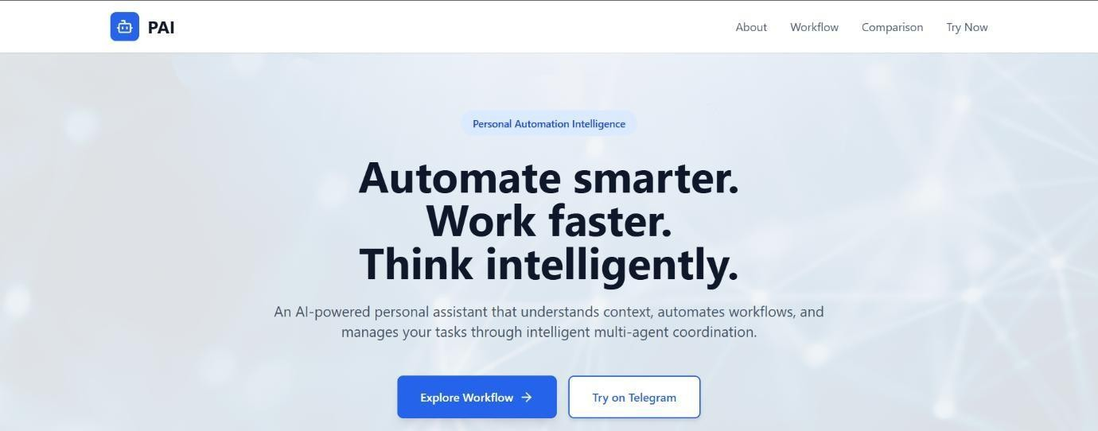
Landing section
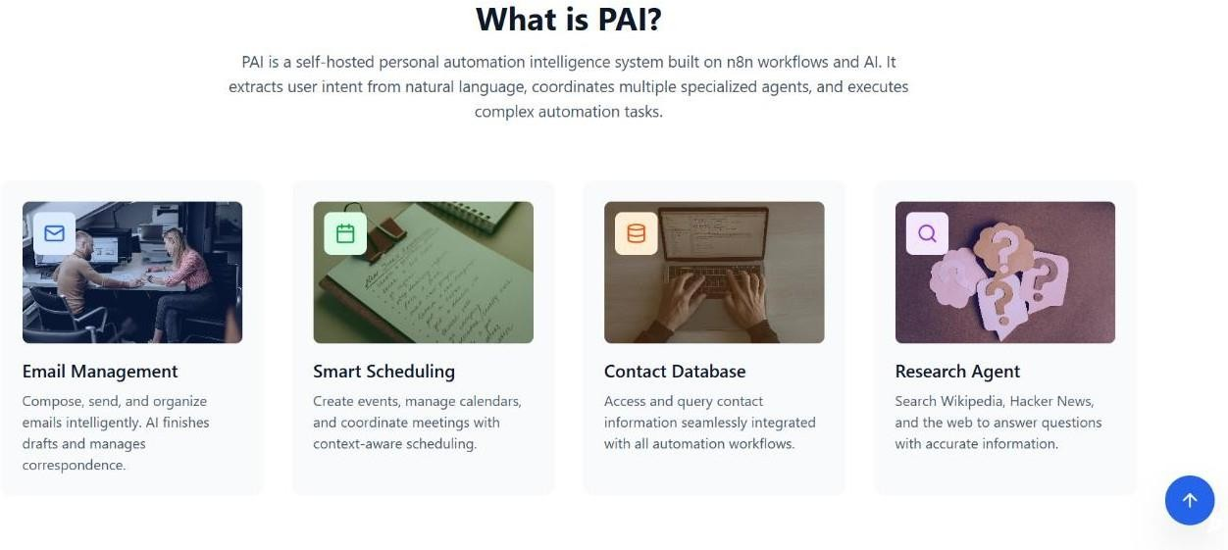
About section

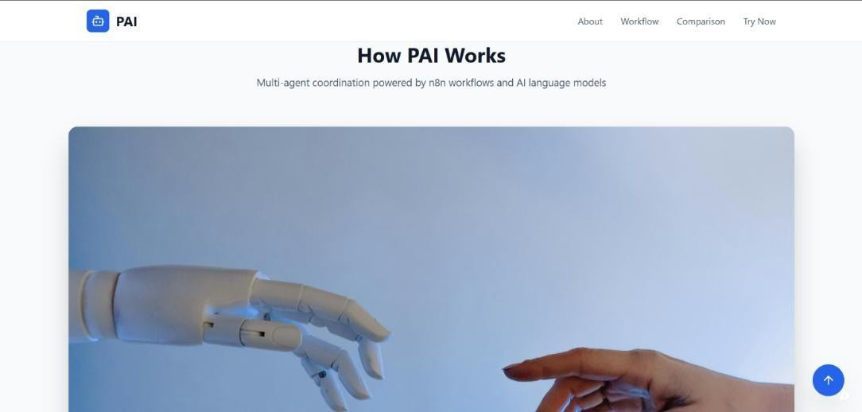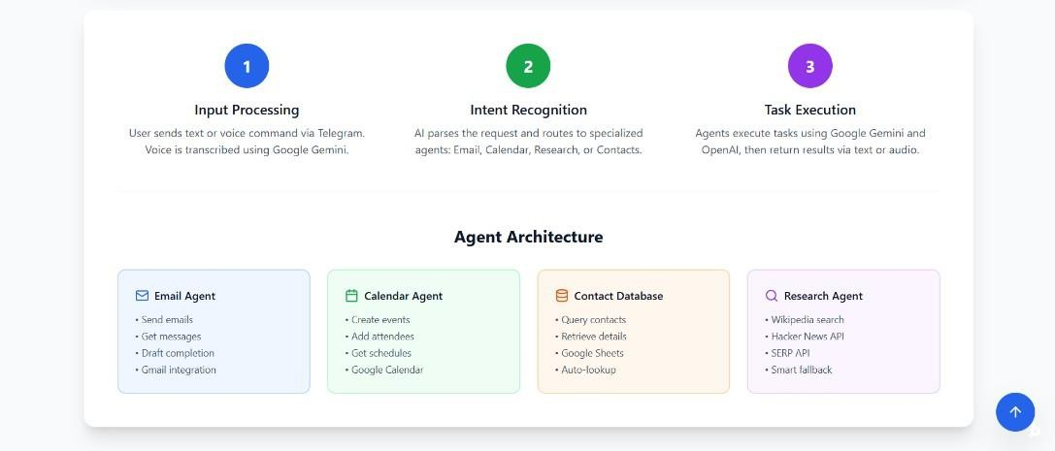
Workflow Section
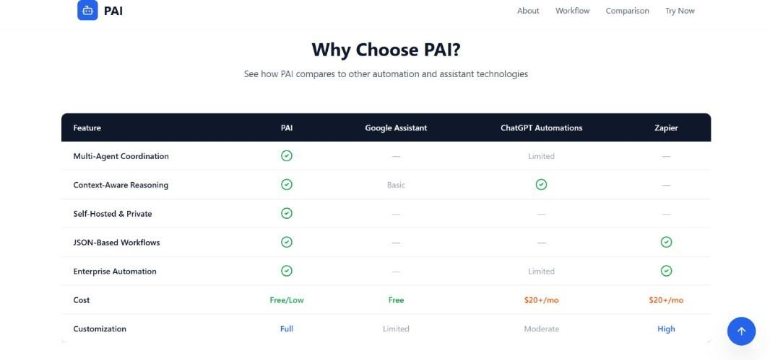
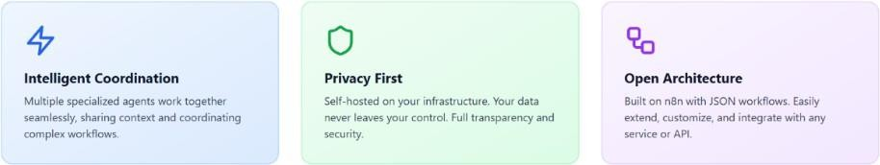

Comparison section

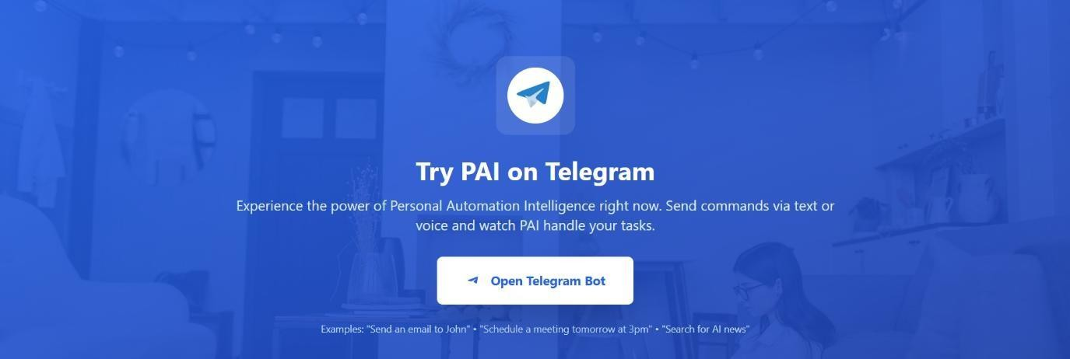
Telegram Chatbot redirection section


Footer Section

    - Backend Workflows
      - PAI Start Workflow

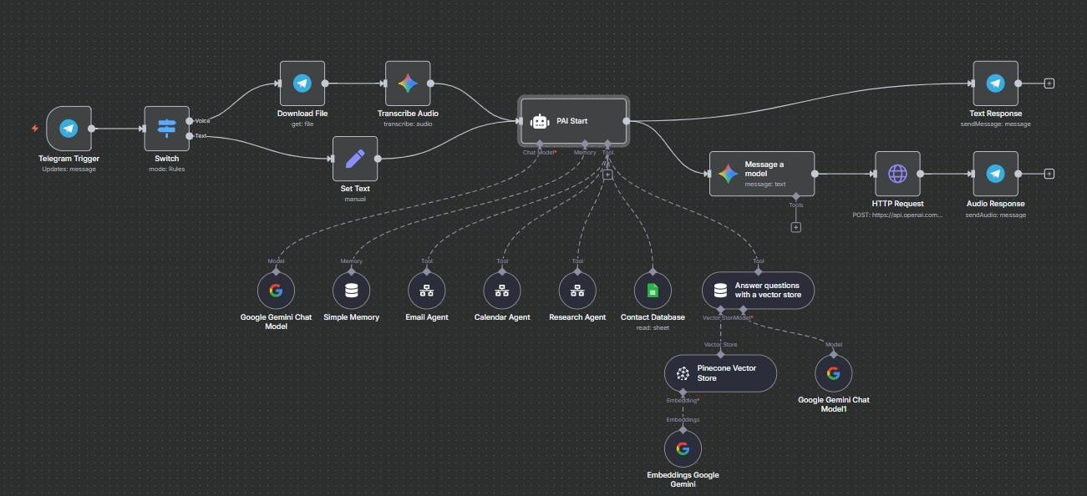

      - Email Agent Workflow
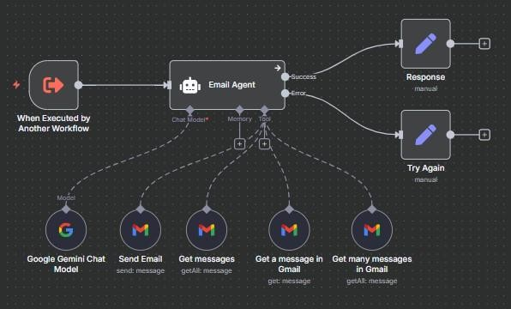
      - Calendar Agent Workflow

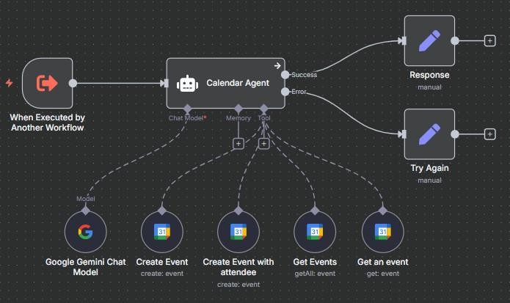

      - Research Agent Workflow
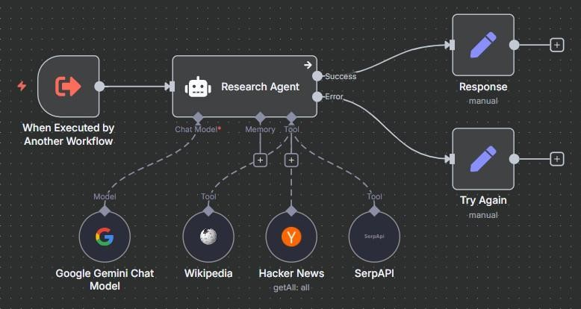

TESTING

TESTING
Testing is an empirical investigation conducted to provide stakeholders with information about the quality of the product or services under test, with respect to the context in which it is intended to operate. This includes, but is not limited to, the process of executing a program or application with the intent of finding a software program/ application/ product that meets the business and technical requirements that guided its design and development, so that it works as expected and can be implemented with the same characteristics. Testing is one of the most critical phases in the Software Development Life Cycle (SDLC). It ensures that the developed system functions correctly, reliably, and efficiently under various conditions.
For PAI – Personal Automation Intelligence, testing validates both the AI-powered logic and the automation workflows built using n8n. Since the system integrates multiple APIs and external services, comprehensive testing was carried out to verify:

- The correctness of workflow execution.
- The reliability of third-party API integrations.
- The response accuracy of AI models.
- The stability of interactions between modules such as Email, Calendar, Research, and Voice.

SYSTEM TESTING
System Testing focuses on verifying the behavior of the complete system as a unified application. This phase ensures that all components — AI, automation, APIs, and user interfaces
- work harmoniously to deliver the desired output.

Objectives:

  - Validate overall system functionality against project objectives.
  - Confirm data flow and communication between modules.
  - Ensure that both text and voice interactions are processed accurately.
  - Verify that user commands lead to the correct automation actions.

Methodology:

System testing was performed using black-box testing techniques. Each user command was treated as input, and the system’s response was observed without analyzing internal code logic.

Test Environment:

  - Operating System: Ubuntu 22.04 LTS
  - Workflow Platform: n8n (self-hosted)

  - APIs Integrated: Gmail API, Google Sheets API, Google Calendar API, OpenAI API, Gemini API, SerpAPI, Hacker News API
  - Testing Tools: Postman (for API testing), n8n Execution Log, Google Cloud Console (for monitoring API calls)

System Test Scenarios:

Test Case ID | Scenario Description | Expected Result
ST01 | User sends a voice command “Send an email to Rahul about project update.” | Email sent successfully, confirmation received via Telegram.
ST02 | User asks, “What meetings do I have tomorrow?” | Calendar Agent retrieves scheduled events for the next day.
ST03 | User says, “Summarize today’s top AI news.” | Research Agent fetches and summarizes data from Hacker News and SerpAPI.
ST04 | User says, “Add a new contact named  Ananya with email ananya@gmail.com.” | Contact entry added successfully to  Google Sheets.
ST05 | Network failure occurs during API call. | Orchestrator retries the request or returns fallback response.

Result:
All core functionalities passed system testing successfully, with error-handling mechanisms performing as expected during simulated API failures.

INTEGRATION TESTING
Integration Testing ensures that the interfaces between different modules work correctly. Since PAI consists of multiple modules that communicate through API calls, integration testing was crucial to confirm the smooth data flow between them.

Objectives:

- Verify module-to-module data exchange.
- Confirm API authentication and token management.
- Ensure that the Orchestrator correctly routes user commands.
- Check dependency consistency across workflows.

Approach:

Integration testing followed an incremental testing approach, meaning each module was integrated and tested one at a time. Once validated, additional modules were added to form a fully functional system.

Modules Tested:

- Orchestrator + Contact Database
- Orchestrator + Email Agent
- Orchestrator + Calendar Agent
- Orchestrator + Research Agent
- Voice Processing + Orchestrator

Integration Workflow Example:

When a user issues the command:

“Email meeting notes to Riya and schedule a review meeting tomorrow.” The test verified that:
  - Orchestrator correctly identified two separate actions (Email + Schedule).
  - Email Agent fetched Riya’s email from Google Sheets and sent the message.
  - Calendar Agent created an event for the next day.
  - Both results were returned as a combined confirmation message.

Result:
All modules successfully communicated, and cross-module actions executed without data loss or duplication.

UNIT TESTING
Unit Testing validates the smallest individual components of the system. Each function, workflow, or module node is tested in isolation to ensure correctness.

Since PAI is implemented primarily through n8n workflows, each workflow and function node represents a “unit.”

Unit Testing Objectives:

- Validate logic within each workflow (e.g., email formatting, data extraction).
- Test AI prompt-response consistency.
- Ensure each API node executes without failure when provided with valid input.
- Confirm correct data retrieval and storage from Google Sheets.

Sample Units Tested:

Unit Name | Purpose | Test Performed | Expected Output
Intent Detection Node | Determines command type | Input: “Schedule meeting tomorrow.” | Output: “calendar_event”
Email Sending Node | Sends email via Gmail API | Input: Name + Message | Email successfully sent
Google Sheets Lookup | Fetches contact details | Input: “Rahul” | Returns Rahul’s email
Research Query Node | Fetches web information | Input: “Latest AI trends” | Returns summarized article list
TTS Node | Converts text to voice | Input: Text “Hello, user.” | Generates playable audio output
Result:
Each workflow node operated correctly in isolation, with proper data validation and error handling.

TEST CASE 1: EMAIL AUTOMATION
Test Case ID: TC01 Module: Email Agent
Description: Verify that the system sends an email successfully when provided with recipient and message details.
Preconditions: User contact exists in Google Sheets; Gmail API credentials authenticated.
- Send “Send an email to Riya about project status.”

Test Steps:

Expected Output:
- System retrieves email from Contacts Table.
- Gmail API composes and sends message.
- Confirmation message displayed. “Email successfully sent to Riya.”

Actual Output: Matches expected.
Status: ⬛ Pass

TEST CASE 2: EVENT SCHEDULING
Test Case ID: TC02
Module: Calendar Agent
Description: Verify creation of a calendar event based on a natural language command.
Preconditions: Calendar API enabled and authenticated; Contact exists in Google Sheets.
- Send command: “Schedule meeting with Rahul at 4 PM tomorrow.”
Test Steps: 2. Extract entities (name, date, time).
- Google Calendar API creates event.
- Confirmation returned to user.
Expected Output: “Meeting with Rahul scheduled for tomorrow at 4 PM.”
Actual Output: Matches expected.
Status: ⬛ Pass

TEST CASE 3: RESEARCH QUERY
Test Case ID: TC03
Module: Research Agent
Description: Verify AI summarization of research content from SerpAPI and Hacker News.
Preconditions: APIs enabled and reachable; Orchestrator active.
- User inputs: “What’s new in Artificial Intelligence?”

Test Steps:

Expected Output:
- SerpAPI fetches relevant results.
- OpenAI summarizes articles.
- Output displayed via Telegram.
“Latest AI trends include multimodal models and reinforcement learning advancements.”

Actual Output: Matches expected.
Status: ⬛ Pass

TEST CASE 4: VOICE INTERACTION
Test Case ID: TC04
Module: Voice Processing Module
Description: Verify system accuracy in speech-to-text and text-to-speech interactions.
Preconditions: OpenAI Whisper and TTS APIs integrated.
Test Steps: 1. Speak command: “Tell me my schedule for today.”
- STT converts speech to text.

Test Case ID: TC04
- Orchestrator identifies command type.
- Calendar Agent retrieves events.
- Response converted back to audio and played.
Expected Output: Assistant reads aloud: “You have one meeting with Riya at 4 PM.”
Actual Output: Matches expected.
Status: ⬛ Pass

  - TESTING TOOLS USED

Tool | Purpose
n8n Editor Execution Logs | Monitored workflow execution and response times
Google Cloud Console | Verified API usage and quotas
Telegram Chat Interface | Tested message delivery and responses
OpenAI Playground | Tested AI responses for intent classification and summarization
Google Sheets UI | Verified data storage and logging accuracy
  - TEST SUMMARY

Test Category | Total Cases | Passed | Failed | Remarks
Unit Testing | 15 | 15 | 0 | All nodes validated successfully
Integration Testing | 10 | 10 | 0 | Modules synchronized effectively
System Testing | 8 | 8 | 0 | End-to-end operations verified
Voice Interaction | 4 | 4 | 0 | Accurate for supported languages
Error Handling | 5 | 5 | 0 | Fallbacks and retries performed correctly

  - SCREENSHOTS

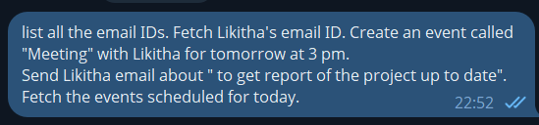

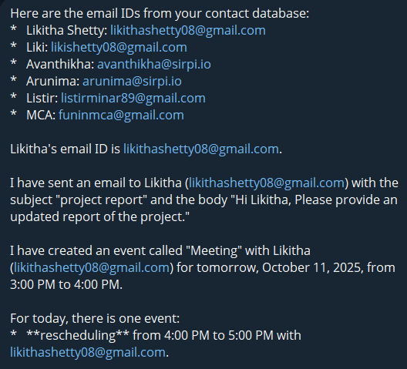

Test Case 1

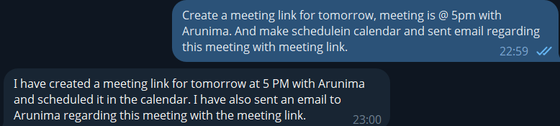
Test Case 2

Test Case 3



Test Case 4
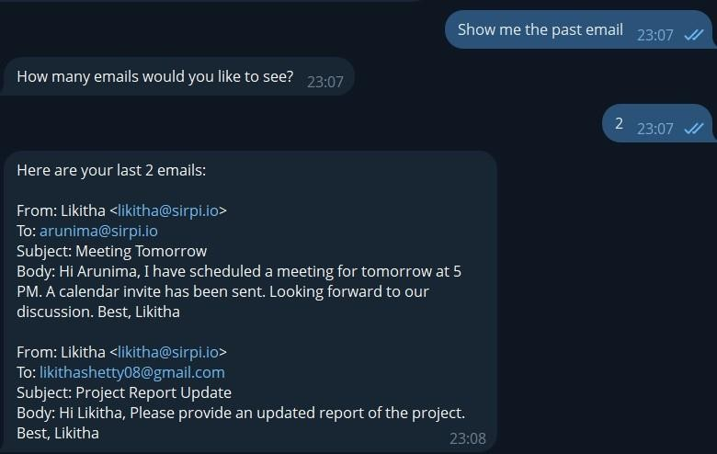

Test Case 5
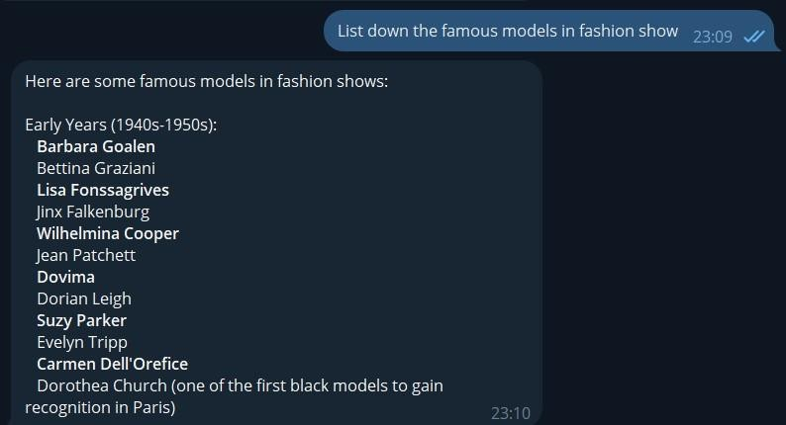

Test Case 6

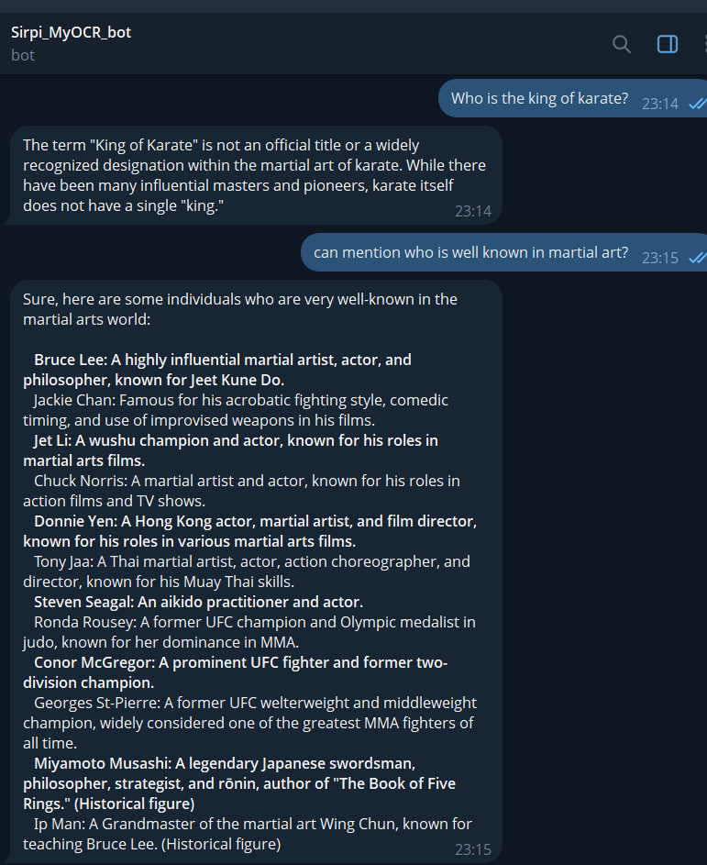
Test Case 7

CONCLUSION

CONCLUSION
The development of PAI – Personal Automation Intelligence (Personal Assistant AI Agent using n8n Workflow Automation) marks an important step toward integrating artificial intelligence with workflow automation to create a personalized, intelligent assistant. The project demonstrates how open-source technologies and modern AI APIs can be combined to deliver a scalable, modular, and context-aware digital assistant capable of performing real- world automation tasks.

Through this system, users can interact using natural language — either by text or voice — and delegate routine operations such as sending emails, managing calendars, retrieving research information, or summarizing content. The assistant leverages powerful APIs such as Google Cloud Console, Google Sheets API, Gmail API, Google Calendar API, Gemini API, OpenAI API, SerpAPI, and Hacker News API to provide comprehensive automation in a user-friendly and privacy-conscious manner.

Summary of Achievements
The project successfully achieved its core objectives defined in the design phase:

Intelligent Natural Language Understanding:
PAI integrates OpenAI and Gemini APIs to interpret user queries accurately, identify user intent, and extract actionable entities such as names, dates, and topics.

Modular Workflow Automation:
Using the n8n platform, multiple agents such as the Email Agent, Calendar Agent, Research Agent, and Voice Processing Module operate as independent workflows under the central Orchestrator. This modular design allows each component to be extended or replaced without affecting the overall system.

AI + API Synergy:
The combination of AI reasoning and practical API integration enables PAI to execute tasks traditionally handled manually — such as sending structured emails, scheduling meetings, or fetching relevant information.

Voice Interaction Capability:
Voice-based interaction, powered by OpenAI Whisper (Speech-to-Text) and OpenAI TTS (Text-to-Speech), brings human-like communication to the assistant, enhancing accessibility and usability.

Lightweight Data Management:
Instead of complex databases, PAI uses Google Sheets as a dynamic, cloud- synchronized contact storage system. This simplifies maintenance while ensuring reliability and transparency.

Secure and Scalable Infrastructure:
The use of Google Cloud Console for managing OAuth 2.0 credentials ensures

secure, authenticated access to APIs. The system is easily deployable on cloud platforms such as Google Cloud Run or AWS for scalability.

Comprehensive Testing and Validation:
The project underwent detailed unit, integration, and system testing, confirming functional accuracy, performance stability, and strong fault tolerance.

Key Learnings

Throughout the development of this project, several valuable technical and conceptual lessons were learned:

Integration Complexity:
Combining multiple APIs and AI models required precise configuration of authentication, token management, and data formats. Understanding OAuth 2.0 authentication flow was essential to ensure secure communication between modules.

Workflow Optimization:
The n8n automation platform provided immense flexibility but required careful optimization to avoid redundancy and improve execution time. Efficient node linking and proper branching logic were crucial for performance.

AI Prompt Engineering:
The assistant’s ability to interpret user intent heavily depended on well-designed prompts. Fine-tuning these prompts improved response accuracy and reduced false classifications.

Error Recovery and Logging:
Incorporating error-handling mechanisms (retry policies, fallback responses, and structured logs) proved vital for ensuring system resilience and maintainability.

Voice Integration Challenges:
Integrating speech processing introduced challenges related to audio quality, latency, and real-time synchronization. These were mitigated using asynchronous execution in n8n and efficient buffering techniques.

Practical Value of Workflow Automation:
The project reaffirmed that low-code automation tools like n8n can bridge the gap between complex programming and user-friendly AI-driven applications.

FUTURE ENHANCEMENT

FUTURE ENHANCEMENT
Every software system has room for improvement as technology evolves. While PAI – Personal Automation Intelligence currently demonstrates robust automation, AI reasoning, and voice capabilities, there exist numerous possibilities for extending its functionality, scalability, and user experience.

The future enhancement phase focuses on identifying areas where the system can evolve to become even more intelligent, adaptive, and integrated with emerging technologies. These enhancements will transform PAI from a personal assistant prototype into a production-grade intelligent automation platform.

EXPANSION OF AI CAPABILITIES
As artificial intelligence models continue to advance, integrating newer and more capable models will enhance the reasoning and conversational power of PAI.

Proposed Improvements:

Context-Aware Memory:
  - Currently, PAI handles one command at a time. Adding long-term conversational memory would allow the assistant to maintain context across sessions.
  - Example: Remembering past meeting topics, previous user preferences, or recurring tasks.

Adaptive Learning Engine:
  - Implement machine learning algorithms that analyze user behavior and preferences over time.
  - The system could predict user needs, such as automatically scheduling recurring meetings or suggesting follow-up emails.

Multimodal AI Integration:
  - Support for processing not just text and voice, but also images, documents, or screenshots.
  - Example: “Summarize this PDF file” or “Extract names from this business card.”

Emotional Intelligence Module:
  - Incorporate sentiment analysis using AI models to detect the emotional tone of user input.
  - The assistant could tailor responses (formal, cheerful, empathetic) based on detected mood.

INTEGRATION WITH MORE APIS AND SERVICES
While the current version integrates major Google and AI APIs, future versions can connect to additional platforms for broader functionality.

Potential Integrations:

Service | Purpose
Microsoft Outlook & Teams API | Manage corporate emails and meetings.
Slack API | Send notifications and receive real-time updates in workspace chats.
Trello / Notion API | Manage tasks and project boards automatically.
Weather API (OpenWeatherMap) | Provide daily weather forecasts and alerts.
YouTube API | Summarize or fetch trending educational videos.
Drive API | Upload and organize attachments or documents  automatically.
SMS Gateway Integration | Send alerts to mobile phones for reminders or emergencies.
These integrations would extend PAI’s role from being a “personal assistant” to a universal automation hub for multiple productivity tools.

SECURITY AND PRIVACY IMPROVEMENTS
As AI systems handle more sensitive data, security must continuously evolve.

Planned Enhancements:

Multi-Factor Authentication (MFA):
  - Add MFA for user access to the PAI dashboard.

End-to-End Encryption:
  - Encrypt all user communication (including Telegram chats) using secure protocols.

Anonymized Data Logging:
  - Store only necessary logs while removing personal identifiers.

Periodic Security Audits:
  - Conduct automated vulnerability scans of APIs and workflows.

User-Controlled Data Deletion:
  - Provide users with the option to delete their data from the system permanently.

INTELLIGENT NOTIFICATIONS AND PREDICTIVE AUTOMATION
Enhancing the assistant’s ability to act proactively will make it more efficient and adaptive.

Planned Capabilities:

Predictive Scheduling:
  - System predicts recurring events or meetings based on user history and automatically schedules them.

Smart Reminders:
  - Use AI to generate reminders not just by time, but by context (e.g., “Remind me to reply to Priya once I reach office”).

Daily Digest Automation:
  - Automatically summarize the day’s meetings, unread emails, and important news every morning.

Task Prioritization:
  - AI ranks tasks based on urgency and user preferences.

Auto Summary Generation:
  - Summarize long email threads or research documents and store them for easy access.

SUMMARY OF FUTURE ENHANCEMENTS

Enhancement Category | Focus Area | Expected Impact
AI & Learning | Context awareness, memory, emotional intelligence | More personalized user interaction
Workflow Automation | Conditional logic, trigger-based automation | Smarter and proactive system responses
Voice Features | Multilingual and real-time conversation | Broader accessibility
Integrations | API and platform expansion | Increased versatility
Interface | Web & mobile dashboards | Enhanced usability
Cloud Infrastructure | Scalability & reliability | Improved system performance
Security | Data protection & transparency | Increased user trust
Analytics | Insights & visualization | Productivity tracking

Conclusion of Future Enhancement Section

The journey of PAI – Personal Automation Intelligence does not end with its successful implementation; it continues as an evolving platform. With advancements in AI, cloud computing, and automation tools, the project holds immense potential to expand into an all- encompassing intelligent ecosystem.

By implementing these future enhancements, PAI will not only perform predefined tasks but also predict, adapt, and evolve — ultimately becoming a truly autonomous digital assistant for personal and professional life.

REFERENCES

BIBLIOGRAPHY
The successful completion of this project, PAI – Personal Automation Intelligence, was made possible by integrating a range of cutting-edge APIs, open-source tools, cloud services, and research documentation.
This section lists all the key references, resources, and technologies that guided the design, implementation, and testing phases of the system.

  - Books and Academic References
- Pressman, R. S., & Maxim, B. R. (2020). Software Engineering: A Practitioner’s Approach (9th Edition). McGraw-Hill Education.
- Sommerville, I. (2016). Software Engineering (10th Edition). Pearson Education Limited.
- Martin, R. C. (2009). Clean Code: A Handbook of Agile Software Craftsmanship.
Prentice Hall.
- Fowler, M. (2003). UML Distilled: A Brief Guide to the Standard Object Modeling Language. Addison-Wesley Professional.
- Bass, L., Clements, P., & Kazman, R. (2021). Software Architecture in Practice (4th Edition). Addison-Wesley.
- Dean, J., & Ghemawat, S. (2008). MapReduce: Simplified Data Processing on Large Clusters. Communications of the ACM.

These foundational texts provided guidance on software design principles, system architecture, and engineering methodologies applied in the project.

  - Websites and Online Resources
- Google Cloud Console Documentation https://cloud.google.com/docs
→ Used for creating projects, managing APIs, and configuring OAuth 2.0 credentials.
- Google Sheets API Reference https://developers.google.com/sheets/api
→ Reference for managing contact storage, reading/writing spreadsheet data, and performing CRUD operations.
- Google Calendar API Documentation https://developers.google.com/calendar
→ Used for integrating event scheduling, retrieving calendar entries, and handling time-based triggers.
- Gmail API Documentation https://developers.google.com/gmail/api
→ Provided email-sending and retrieval capabilities within n8n workflows.

- n8n Workflow Automation Official Site https://n8n.io
→ Used to design and implement the entire automation architecture.
- OpenAI Developer Documentation https://platform.openai.com/docs
→ Reference for integrating GPT-based text processing, text-to-speech (TTS), and intent classification.
- Gemini API (Google AI Studio) https://ai.google.dev/gemini-api
→ Used for advanced natural language reasoning and context interpretation within workflows.
- SerpAPI Official Documentation https://serpapi.com
→ Used to fetch real-time web data and news articles for research queries.
- Hacker News API https://github.com/HackerNews/API
→ Provided technology-related news data for the Research Agent module.
- Telegram Bot API https://core.telegram.org/bots/api
→ Reference for integrating Telegram as the communication interface for user interaction.
- OAuth 2.0 Authentication Protocol https://oauth.net/2/
→ Used to implement secure API authentication across Google services.
- OpenAI Whisper (Speech-to-Text) and TTS Models https://platform.openai.com/docs/guides/speech-to-text
→ Used for implementing voice input/output in the assistant.
- Docker Documentation https://docs.docker.com
→ For future containerized deployment of the PAI system.
- Postman API Platform https://www.postman.com/
→ Utilized for testing API requests, responses, and verifying authentication credentials.
- GitHub n8n Workflows Community https://github.com/n8n-io/n8n
→ Open-source reference for designing modular automation workflows.

